txt_D4.3_v9_FIN_25oc24

Markowski/Stanley/Zagórski/ Żerkowska-Balas in collaboration with Vukovic, Enyedi, Rovny??

Deliverable 4.3 **A typology on the distribution of the types of illiberal orientations across the EU Member States**

**Introduction**

Present-day Europe is haunted by a number of phenomena that rival contemporary liberal democracies (see for example: Zakaria, 1997; Diamond, 2002; Levitsky & Way, 2002; Merkel, 2004; Bogaards, 2009; Erdmann, 2011; Schedler, 2015; Wodak, 2019; Enyedi 2024). The main ones are populism, illiberalism, and authoritarianism (PIA)[1]. They differ in the extent of their departure from the liberal model and they challenge different aspects of liberal democracies, unveil specific traits and demonstrate idiosyncratic developments (Markowski 2023). Divergent factors determine them and are – most likely – facilitated by different socio-political contexts. These PIA phenomena manifest themselves in different forms; as historical traditions, party programs, contemporary set of ideas, elaborated ideologies and – ultimately – as political regimes. Consequently, these competing with liberal democracies phenomena should be placed within the grand frame of recent history, time sequence, and multiple contextual impacts – economic, cultural, and international.

The literature on the topic is rich, but far from conclusive. Conceptual order is certainly needed. The task of categorizing illiberal regimes is ontologically distinct from analyzing and understanding the essence of illiberal traditions, set of ideas or ideologies. Nevertheless, a comprehensive understanding of either aspect requires an appreciation of both. It is evident that no deterministic relationship exists between the type of political regime and the dominant ideologies (coherent sets of ideas) manifested among the general population. However, a complete lack of alignment between the type of regime and the prevalent popular attitudes shaped by these ideologies is equally improbable. Thus, the precise relationship between regimes and ideologies, as mediated by citizens' beliefs, is an empirical question that must be tested in each instance.

In this paper we focus on the set of ideas indicative of PIA as manifested in peoples' attitudes in seven European countries, each of which experiences (or has experienced in the past) strong anti-liberal tendency in their polities. In some (Hungary, Italy) anti-liberals are in power, in other had been for a significant period (Poland), in still other anti-liberals win elections, even if unable to govern (France, Austria), finally specific anti-liberal trends unveil in public and political domain (Czechia, Great Britain). Analyzing the anti-liberal phenomena we assume the following: first, there are types of anti-liberalism (Enyedi, 2024) (not only PIA, but also more detailed ones); second, contemporary types of anti-liberalisms (even though they might be linked to national traditions) are mainly reactions to the malfunctioning of present-day liberal democracies; third, accordingly we try to associate particular types of anti-liberal attitudes with desirable normative visions of democracy preferred by the citizenry, as we believe certain forms of anti-liberalism are more compatible with the democratic ideas and its performance than other forms.

**Theoretical Foundations**

The core principles of liberal democracy—political rights, pluralism, free and fair elections, the rule of law, etc. —have historically encountered significant resistance and have never achieved universal acceptance. Nevertheless, between 1945 and 2000, these principles gained considerable normative and institutional traction globally. Since the dawn of the 21st century, however, we have witnessed a pronounced democratic recession and an ideological pushback and countertrend against liberal democracy (Alizada et al. 2021). This regression has been accompanied by a growing corpus of normative critiques targeting the philosophical underpinnings, institutions, and practices of liberal democratic governance. In response to these developments, political scientists have acknowledged the necessity of recalibrating theoretical frameworks to more accurately conceptualize and interpret these contemporary dynamics. Consequently, many foundational concepts of 20th-century political science have undergone redefinition, while novel categories and analytical typologies have been introduced to reflect current political realities.

Within this evolving scholarly discourse, three concepts—populism, illiberalism, and authoritarianism (PIA)—have emerged as particularly salient. The literature review provided in Deliverable 2.1 of the AuthLib project offers a comprehensive rationale for emphasizing these ideologies, and here we reiterate its key findings (Markowski et al., 2023).

Liberal democracies (LDs) today confront formidable ideological competitors, most notably in the form of populism, illiberalism and authoritarianism. These political currents challenge liberal democracies along distinct axes, each characterized by its own ideological tenets, institutional forms, and developmental trajectories. The rise and consolidation (if it happens) of these regimes are shaped by complex, context-dependent variables rooted in diverse socio-political ecosystems.

On a global scale, alternatives to the liberal democratic model are proliferating with increasing frequency, especially across the Global South. This phenomenon is also observable in states previously regarded as consolidated democracies, such as India, where democratic backsliding has become a salient issue. Furthermore, a noticeable erosion of liberal democratic norms is evident in long-established democracies, including the United States, Italy, France, and Austria, signaling a broader, transnational retreat from the liberal democratic paradigm.

Disenchantment with and opposition to liberal democracy manifests in various ideological and political forms, including ethnopopulism (Vaduchova 2020), authoritarianism (Glasius 2018), paternalistic populism (Enyedi 2015), technocratic populism (Bustikova & Guasti 2018), nationalism (Varga & Buzogany 2022), authoritarian cientelism (Markowski 2019) and Euroscepticism (De Vries 2018). Many scholars emphasize the ontological distinctiveness of polities that have been under illiberal governance for extended periods. Hungary, and to a lesser extent Poland and Italy, are prominent European examples where populist and illiberal parties have maintained power for a significant duration, sparking scholarly interest in the mechanisms of political consolidation and regime entrenchment in these contexts (Pirro, Stanley 2022).

To comprehend the complex dynamics of alternatives to liberal democracies (ALDs), it is crucial to situate these phenomena within a broader temporal and historical framework, recognizing the interplay of economic, cultural, and international factors. These contextual variables shape the emergence, trajectory, and consolidation of anti-liberal regimes, but no deterministic causal relationship between regime type and the dominant ideological orientation of the citizenry can be assumed. Historical cases, such as Poland under communist rule, underscore the potential disjunction between political regimes and public attitudes. Nevertheless, while not deterministic, it is implausible to assume a complete dissociation between the nature of the political regime and the ideological preferences and beliefs of its populace.

Thus, the relationship between regime type and ideological alignment and sets of ideas, as mediated by citizens' attitudes, constitutes a critical empirical question. It is likely a positive correlation between the ideological orientation of the regime and the public's ideological alignment exists, but the strength and nature of this relationship require case-specific analysis.

Contemporary anti-liberal regimes have not emerged through traditional routes of power seizure, such as military coups or violent revolutions, which characterized much of the political turbulence in the latter half of the 20th century. Instead, these regimes arise through the electoral success of populist and illiberal actors who, while democratically elected, systematically dismantle core liberal democratic principles, particularly the separation of powers and the institutional checks and balances integral to the rule of law. This phenomenon points to a significant portion of the electorate endorsing populist, illiberal, or authoritarian ideologies, policies, and governance models. A key empirical challenge is to assess the extent and distribution of this support—whether it is broadly dispersed across the political spectrum or concentrated within specific demographic or partisan groups.

The precise contours of the anti-liberal-democratic repertoire remain subject to ongoing scholarly debate. One of the central axes of this debate concerns whether tolerance toward minorities and alternative lifestyles is an essential feature of liberal democracy. Conversely, does opposition to such tolerance inherently constitute an illiberal position? This debate further extends to the definition of illiberalism itself, raising questions about whether resistance to executive oversight or opposition grounded in cultural-identity concerns, particularly regarding progressive emancipation movements, should be classified as illiberal. These conceptual ambiguities reflect the broader complexities surrounding the ideological and political contestation of liberal democratic norms.

The analysis of populism within public policy often begins with identifying political leadership that embodies such ideological orientations. However, this binary approach oversimplifies the complex reality: populist, illiberal, or authoritarian policies can be advanced by actors typically aligned with liberal democratic norms, and conversely, liberal democratic policies may emerge from leaders associated with populist or illiberal tendencies. Recent data from the European Social Survey (Round 10), which examines democratic values, reveals that there is broad normative support for the liberal-democratic model across Europe. Yet, those who express higher normative expectations of democracy—such as demands for redistributive justice, increased access to direct democratic mechanisms, or support for a populist notion of democracy where the will of the people overrides institutional checks and balances—tend to advocate for complementary alternatives to liberal democracy rather than outright replacements (Ferrin, Kriesi 2024). This suggests a "cascading" model of democracy, where divergent democratic demands accumulate without necessarily displacing liberal-democratic norms. Thus, an open and flexible conceptual framework is essential for analyzing these phenomena.

Empirically-driven political scientists, such as ourselves, recognize the complexity of anti-liberal phenomena, which encompass populism, illiberalism, and authoritarianism (PIA). These alternatives to liberal democracy (ALDs) resist simplistic categorizations along traditional left-right ideological axes, often blending elements of broader "thick" ideologies such as nationalism, conservatism, or even elements of socialism. Extensive research detailing the intersecting and divergent characteristics of these three forms of ALDs is available, including visual models that delineate their ideological overlaps. Here, we provide a concise synthesis of key insights.

At the core of populism, illiberalism, and authoritarianism are several shared ideological tenets, including a majoritarian understanding of democracy, skepticism toward representative institutions, anti-globalization sentiment, and, in some cases, a Manichean worldview that divides society into a virtuous "people" and a corrupt elite. Despite these commonalities, key distinctions set them apart. Populism is primarily characterized by anti-elitism, anti-establishment rhetoric, and a focus on the sovereign will of "the people" (people-centrism), which are less central to illiberalism and authoritarianism. Conversely, illiberalism and authoritarianism are defined by their opposition to foundational liberal democratic principles, such as media independence, the protection of civil society, judicial autonomy, and horizontal accountability. These regimes are often marked by an aversion to secularization, the development of clientelistic networks, and an adherence to traditional social and political hierarchies, including an emphasis on law and order (Markowski et al., 2023).

The use of coercion and repression distinguishes authoritarian regimes from illiberal democracies. While illiberal regimes may restrict avenues for dissent, limit political participation, and subvert the rule of law to entrench their rule, they generally avoid the direct use of violent repression against their populations. Authoritarian regimes, on the other hand, are characterized by institutionalized violence, repression of political opposition, and the systematic suppression of dissent. Another significant distinction lies in electoral integrity: illiberal regimes often undermine elections through informal, diffuse anti-democratic practices, whereas authoritarian regimes typically employ more formalized, rigid mechanisms of electoral manipulation. Although illiberal regimes erode civil liberties and democratic freedoms, some degree of these liberties may still exist, in contrast to authoritarian contexts where they are systematically absent.

Illiberalism, in particular, merits focused attention within political science discourse. It is marked by a deep antagonism toward individual liberties, a rejection of individualism, and an entrenched disregard for minority rights, especially in cultural and social domains. While populism and authoritarianism may also exhibit these traits, they are rarely central to their ideological core. Illiberal regimes challenge the normative assumptions of liberal democracy by privileging collective identity over individual rights and by fostering a political environment that is explicitly hostile to pluralism and minority protections. Illiberalism – simultaneously – emphasizes the role of the state, its sovereignty, revels distaste for globalization and international rules and institutions. These traits are typically coupled with clear fear of foreigners, immigrants, and – in fact, all defined as – aliens; the fear that is grounded in conspiracy beliefs. These distinctive characteristics make illiberalism an important concept for understanding the broader landscape of democratic backsliding in both established and emerging democracies.

The basic premise of AuthLib is that liberal democracy faces not one ideological challenge but many and that we lack a thorough understanding of these challenges. To obtain a comprehensive account of the alternatives to liberal democracy that emerged across and within countries in Europe in recent years, the project carefully and systematically explores the varieties of alternatives to liberal democracies and their appeal. These alternatives have diverse ways of appealing to elites, citizens, and specific social groups. These appeals include narratives, programs and policies, emotional triggers, institutional innovations, and sophisticated methods of diffusion, each of which needs to be understood and mapped. To achieve these goals, AuthLib addresses the following key objective: map the varieties of populism, illiberalism, and authoritarianism and citizens' responses to them. The project as a whole focuses thus on a set of ideas, ideologies, political institutions and – where applicable – on emerging political regimes. In this deliverable, we concentrate on ideas and ideologies as manifested in people’s attitudes, opinions and preferences.

We also claim that the challenges to the liberal democratic order are not purely a protest against the status quo but clearly also an expression of alternative ideals derived from historical and intellectual traditions. Our analyses focus as well on the ways in which liberal democracy is perceived by its critics.

However, our key focus in this paper is on citizens opinions, attitudes and preferences, that is why it should be noted that fair competition and other basic democratic practices can be undermined not only from above, but also from below, by the citizens themselves. Many voters seem to turn a blind eye to the populist, illiberal and authoritarian departures from ideals of liberal democracy if they are tide to implementation of policies that are in line with their ideological leaning. It has been shown that, especially in polarized electorates (Svolik 2019), citizens are willing to trade off democratic norms such as judicial independence, checks-and-balances mechanisms or civil liberties, for partisan interests and goals.

**Research Questions**

Our study is primarily descriptive and exploratory in nature. However, "primarily" does not mean exclusively, as we present both an initial test of the theoretical framework, in which our research question is deeply rooted in the literature and theory, and also test reality in a purely descriptive-inductive manner. In the latter, we are driven by curiosity, and we seek to understand how various aspects of phenomena that are often considered incompatible with the theory of liberal democracy manifest themselves in practice, specifically in the consciousness of citizens from seven EU countries. Furthermore, we aim to connect individuals' attitudes and beliefs regarding populist, illiberal, or even authoritarian solutions with their visions of democracy, their sociodemographic characteristics, and their party preferences.

Starting from the theoretical outline of populism, illiberalism, and authoritarianism PIA (presented in the previous section), which is designed to distinguish between the three concepts and phenomena, a series of simple and in-depth analyses using Confirmatory Factor Analysis (CFA) have been conducted. We performed these analyses in various configurations, controlling for different variables. In each case, the ultimate aim was to analyze a configuration of factors that represents the "core" of these three concepts and phenomena (see the next section, "Operationalization"). Therefore, the first research question (RQ1) focuses on whether these three phenomena (in the form of citizens' attitudes) are distinct and what their theoretically expected relationships are.

For this, we estimated a confirmatory factor analysis (CFA) model with three factors, reflecting our theoretical expectation that populism, illiberalism, and authoritarianism constitute distinct but correlated latent variables. The final model most accurately aligned with the theoretical assumptions about the ontological nature of populism, illiberalism, and authoritarianism is presented in Table 1.

Next, we approached the same issue by removing the theoretical lens and allowing empirical evidence to reveal the reality of PIA. More specifically, we analyzed a much larger set of factors, which potentially served as indicators (and sometimes as mere correlates) of these three concepts and phenomena in Principal-Component Factor Analysis (PCA). In this case, our analyses aimed at descriptively reconstructing the empirical reality as it is, without any theoretical framework. Of course, the list of factors analyzed was derived from recognized literature in the field, but it was broad, aiming to encompass diverse research approaches and (sometimes controversial) ideas about the essence of these three phenomena. Our primary goal was to capture all possible configurations and subtypes (if they exist) of the phenomena under study.

In other words, we assumed the existence of variations and diversity within populism, illiberalism, and authoritarianism. Thus, the main research question (RQ2) was whether there are variations of these three phenomena, whether their variants form logical syndromes, whether they are independent of one another and to what extent, and whether they are universal (i.e., similar across all countries) or display significant cross-national differences?

Ultimately, we tested whether PIA attitudes were more prevalent among certain socio-demographic groups, and how they translate to electoral behavior, i.e. support for populist radical right parties. We also examine the relationship between the intensity of these attitudes among citizens who support one of the two visions (models) of democracy: liberal and populist. Although there are more normative visions and models of democracy revealed among Europeans (see Ferrin, Kriesi 2016; 2024), for our analysis focused on understanding attitudes toward liberal democracy and its alternatives, these two models suffice. These models are normative expectations of citizens regarding democracy; operationally, we asked respondents (similarly to the ESS surveys, modules 6 and 10) whether a particular aspect of democracy should, and to what extent, be considered part of democracy.

The specific research question (RQ3) in this case pertains to whether we can expect individuals with certain socio-demographic characteristics (older, males, less educated), supporters of radical right parties, and those who support and accept the existence of the populist model of democracy to exhibit higher levels of populism, illiberalism, and authoritarianism or whether these traits are evenly distributed across basic social groups, electorates, and both normative visions of democracy.

**Operationalization**

Our main dependent variables – populism, illiberalism, and authoritarianism – were operationalized a priori in only one of the two versions of their analysis, specifically the one that tested our theoretical propositions regarding populism, illiberalism, and authoritarianism.

Following the basic dimensions of populism identified in the literature (anti-elitism, people-centrism, Manichean outlook) and adding a measure of simplism, the indicator questions for populism were:

To what extent do you agree or disagree with the following statements? (1=Strongly agree; 5=Strongly disagree)

1. Politics is ultimately a struggle between good and evil
2. The will of the majority should always prevail, even over the rights of minorities
3. The [COUNTRY] is pretty much run by a few big interests looking out for themselves
4. Politicians constantly over-complicate simple matters instead of effectively solving them

Illiberalism is complex and multidimensional concept. In our research we follow the proposal submitted by Laurelle (2022:309), in which - after a thorough analysis of its contemporary manifestations – she proposes its core traits, as follows: (a) It represents a backlash against today's liberalism in all its political, economic, cultural, geopolitical, and civilizational scripts, often in the name of democratic principles and by winning popular support. (b) It proposes majoritarian, nation-centric or sovereigntist solutions, favoring traditional hierarchies and cultural homogeneity. (c) It proposes to restore national sovereignty in various spheres: internationally, by rejecting supranational and multilateral institutions in favor of the sovereign nation-state; economically, by denouncing neoliberal orthodoxy and promoting protectionism at the nation-state level (while at the same time, when in power, sometimes implementing neoliberal reforms); and culturally, by rejecting multiculturalism and minority rights in favor of majoritarianism

Hence, the indicators used to measure illiberalism were the following:

To what extent do you agree or disagree with the following statements? (1=Strongly agree; 5=Strongly disagree)

1. What our society needs is protection against international influences, not further opening-up
2. Leaders should always follow the interests of their country, even if this means going against international rules.
3. It is impossible for an organization to serve the interests of our nation if most of its funding comes from foreign sources
4. Those who claim that there are powerful organizations in the world which conspire against the [COUNTRY] have a good point.
5. These days the leading contribution white people have made to human culture is being downplayed

Finally, authoritarianism was operationalized as follows:

Listed below are a number of statements. To what extent do you agree or disagree with each of them? 1=Strongly agree; 5=Strongly disagree)

1. Obedience and respect for authority are the most important virtues children should learn

2. The government should be able to bend the law in order to solve pressing social and political problems

and

How acceptable for you would it be for the [COUNTRY] to have a strong leader who is above the law? (0=Not at all acceptable; 10=Completely acceptable)

The list of variables/questions used in the second descriptive-inductive analysis of PIA is provided in Part 2 of the Results section.

Meanwhile, the indicators for the two normative visions of democracy are identical to those in the recognized European Social Survey in modules 6 and 10.

For the *populist* normative vision of democracy, the following questions were used:

"How important do you think it is for democracy in general… (0=Not at all important for democracy; 10=Extremely important for democracy)

1. …that citizens have the final say on the most important political issues by voting on them directly in referendums?
2. …that the views of ordinary people prevail over the views of the political elite?

3. …that the will of the people cannot be stopped?"

For the *liberal* model of democracy, a set of questions were asked:

"How important do you think it is for democracy in general… (0=Not at all important for democracy; 10=Extremely important for democracy)

1. …that the media are free to criticize the government?
2. …that the rights of minorities are protected?
3. …that the courts treat everyone the same?"

**Results**

**(1) Theory-testing approach**

As mentioned in previous sections, a theoretical outline of populism, illiberalism, and authoritarianism PIA was presented, designed to distinguish between the three concepts and phenomena. Our empirical analyses comprised a series of simple and in-depth analyses using Confirmatory Factor Analysis (CFA). We performed these numerous analyses in various configurations, controlling for different variables. In each case, the ultimate aim was to detect a configuration of factors that represents the "core" of these three concepts and phenomena. The one that is presented in Table 1 seems the most convincing in terms of what really these concepts are, how they differ, and what their resemblances are. The model accounts for the ordinal character of the data and applies sampling weights.

**Table 1**. Confirmatory Factor Analysis of core PIA indicators

Latent Variables:

Estimate Std.Err z-value P(>|z|)

pop_core =~

P11_05r 0.597 0.017 34.888 0.000

P11_06r 0.567 0.014 39.639 0.000

P11_07r 0.607 0.015 40.430 0.000

illib_core =~

P12_01r 0.800 0.008 94.934 0.000

P12_02r 0.720 0.010 72.002 0.000

P12_04r 0.641 0.011 57.128 0.000

P12_05r 0.648 0.011 61.598 0.000

aut_core =~

P3 0.589 0.017 33.788 0.000

P4_01r 0.600 0.017 34.518 0.000

P11_08r 0.524 0.017 30.684 0.000

Covariances:

Estimate Std.Err z-value P(>|z|)

pop_core ~~

illib_core 0.675 0.015 44.874 0.000

aut_core 0.286 0.023 12.605 0.000

illib_core ~~

aut_core 0.598 0.017 35.618 0.000

At this point, let us interpret them shortly. Our confirmatory factor analysis (CFA) of the PIA variables lends moderate support to the theory that populism, illiberalism, and authoritarianism are correlated but – at the same time - distinct latent variables. The RMSEA of 0.08 is pretty moderate, but the factor loadings are reasonably strong.

It is interesting to note that there is a strong correlation between populism and illiberalism (0.83), and a strong, if slightly weaker, correlation between illiberalism and authoritarianism (0.74). However, the correlation between populism and authoritarianism is, at 0.47, positive but moderate.

In terms of the content of these three core concepts (we will call them in this paper: core-populism, core-illiberalism, and core-authoritarianism to distinguish them from the PIA concepts that are constructed inductively in the next section of the paper), the following traits are the key features of:

core-populism:

(i) majority dominance ("the will of majority should always prevail, even over the rights of minorities");

(ii) economic elite/big business power ("The COUNTRY is…run by a few big interests looking out for themselves");

(iii) simplism ("Politicians constantly over-complicate simple matters instead of effectively solving them".

Theoretical literature and numerous empirical accounts support such a view of the essence of populism (Mudde, 2004; Hawkins, 2009; Castanho Silva et al., 2018; Urbinati, 2019)

core-illiberalism:

(i) rejection of globalism ("What our society needs is protection against international influences, not further opening up");

(ii) state-centered nationalism ("Leaders should always follow the interest of their own country, even if this means going against international rules");

(iii) conspiracy assumption ("Those who claim there are powerful organizations in the world that conspire against [COUNTRY] have a good point");

(iv) ethnic/racist superiority ("These days the leading contribution white people have made to human culture is being downplayed")

Literature on illiberalism points also clearly to the more cultural-driven factors than the ones featuring in our core-illiberalism, however the above mixture of concerns with the role of the national state in a globalized world controlled by influential conspiring organizations coupled with a conviction that the non-white global majority is downplaying the role of developed world's contribution to the global well-being.

core-authoritarianism

(i) unchecked leadership ("How acceptable for you would it be for the [COUNTRY] to have a strong leader above the law")

(ii) socialization into obedience /social conformism ("Obedience and respect for authority are the most important virtues children should learn")

(iii) acceptance of law flexibility ("Governments should be able to bend the law in order to solve pressing social and political problems")

These three elements are by far the most important elements of contemporary authoritarian attitudes; they cover the social component and two facets of citizens' acceptance of public/political procedure. All three have been tested and re-tested in the two most acclaimed contemporary survey projects, of the European Social Survey (ESS) and World Values Survey (WVS), as key indicators of authoritarian attitudes.

**(2) Descriptive-Inductive Analysis**

As noted at the outset, we strongly advocate for distinguishing between populism, illiberalism, and authoritarianism (PIA) as three distinct concepts and phenomena, each manifesting as a syndrome of attitudes. Additionally, we proposed that different variants of these phenomena may exist. More broadly, we hypothesized that beyond these three categories, other configurations of attitudes—somewhat correlated with PIA—could emerge within the public consciousness, requiring new terminologies.

To explore this, our current analysis utilizes a substantially larger set of indicators, alongside the statistical method of Principal Component Analysis, which allows for the empirical identification of new attitudinal configurations. Table 2 presents the overall relationships between all 21 indicators employed in this and subsequent analyses (all variables were standardized and data weighted).

**Table 2**. PCA of PIA pooled (all variables, all countries), rotated factor loadings.

|  |  |  |  |  |  |  |  |
| --- | --- | --- | --- | --- | --- | --- | --- |
|  |  | F1 | F2 | F3 | F4 | F5 | *Uniq.* |
| Variable | *Proportion of explained variance* | *0.13* | *0.13* | *0.10* | *0.09* | *0.07* |  |
| P11_04 | (P) Politics is ultimately a struggle between good and evil | 0.17 | -0.13 | 0.35 | 0.27 | 0.39 | *0.61* |
| P11_05 | (P) The will of the majority should always prevail… | 0.24 | 0.28 | 0.15 | 0.36 | 0.13 | *0.69* |
| P11_06 | (P) [Country] is pretty much run by a few big interests…. | -0.05 | 0.06 | 0.78 | -0.05 | -0.03 | *0.39* |
| P11_07 | (P) Politicians constantly over-complicate simple matters… | -0.08 | 0.05 | 0.74 | 0.16 | -0.13 | *0.40* |
| P4_03 | (I) Women should be prepared to cut down on paid work… | 0.52 | 0.19 | 0.00 | 0.18 | 0.19 | *0.63* |
| P4_04 | (I) Same‐sex marriages should be prohibited by law | 0.74 | 0.19 | 0.04 | 0.11 | -0.03 | *0.40* |
| P4_05 | (I) Women should be free to decide on matters of abortion (rev) | 0.64 | -0.02 | -0.06 | -0.21 | -0.03 | *0.54* |
| P4_06 | (I) Teaching teenagers about tolerance towards transgender… | 0.61 | 0.28 | 0.04 | 0.19 | 0.02 | *0.51* |
| P4_07 | (I) These days you cannot even say what you think about… | 0.14 | 0.43 | 0.17 | 0.42 | -0.09 | *0.58* |
| P4_08 | (I) Those who don't believe in God are not suitable for govern… | 0.68 | -0.07 | -0.04 | 0.12 | 0.16 | *0.49* |
| P12_01 | (I) What our society needs is protection against international…. | 0.32 | 0.45 | 0.41 | 0.24 | 0.23 | *0.42* |
| P12_02 | (I) Leaders should always follow the interests of their country… | 0.26 | 0.34 | 0.45 | 0.25 | 0.16 | *0.53* |
| P12_03 | (I) It is impossible for an organisation to serve the interests… | 0.25 | 0.27 | 0.38 | 0.11 | 0.22 | *0.66* |
| P12_04 | (I) Those who claim that there are powerful organisations… | 0.36 | 0.22 | 0.43 | 0.07 | 0.33 | *0.53* |
| P12_05 | (I) These days the leading contribution white people have… | 0.36 | 0.47 | 0.25 | 0.22 | 0.12 | *0.53* |
| P6 | (I) Immigrants bad for the economy | 0.05 | 0.85 | 0.04 | 0.02 | 0.03 | *0.27* |
| P7 | (I) Immigrants bad for culture | 0.06 | 0.87 | 0.06 | 0.07 | 0.02 | *0.23* |
| P3 | (A) How acceptable for you would it be to have a strong leader… | 0.00 | 0.12 | -0.09 | -0.05 | 0.79 | *0.35* |
| P11_08 | (A) The government should be able to bend the law in order… | 0.13 | -0.11 | 0.04 | 0.42 | 0.52 | *0.52* |
| P4_01 | (A) Obedience and respect for authority are the most important… | 0.17 | 0.07 | -0.01 | 0.74 | 0.11 | *0.41* |
| P4_02 | (A) People who break the law should be given much harsher… | -0.05 | 0.18 | 0.17 | 0.68 | -0.07 | *0.47* |

Notes: Scale reliability coefficient: 0.8276; In red: >0.4 loading; In yellow: >0.15 loading of an item across at least 4 factors out of 5.

This general overview, illustrating the relationships among all the analyzed indicators, suggests the existence of at least five syndromic clusters: one related to populism (F3), two to illiberalism (F1 and F2), and two to authoritarianism (F4 and F5). This structure is compelling, as the scale reliability coefficient is high (.83), and the variables highlighted in red, which appear to be firmly and systematically interconnected, have factor loadings of at least .4.

Factor 3, corresponding to what we term populism, could be labeled *anti-elitist parochialism*. However, it suggests that this cluster comprises a robust anti-elitist component alongside another element that may not always co-occur with the anti-elitist stance. We will attempt to resolve this issue in the next phase of our analytical inquiry.

There are also two variants of illiberalism (factors 1 and 2). The first can be described as *Illiberal traditionalism* (or *Illiberalism as Traditionalism*), while the second represents *Nativist Illiberalism* (or *Illiberalism as Nativism)*. The latter also contains a significant feature—an association with what can be termed the sense of a minority/exclusionary status of the titular majority.

Finally, factors 4 and 5 point to the existence of two forms of authoritarianism. The first, which can be called *social authoritarianism*, reflects an attitude of punitiveness mixed with a vision of socialization into obedience. The second, termed *political or power-related authoritarianism*, focuses on political power. At this point, it is important to note that in both types of authoritarianism, a critical element is the acceptance of the view that "the government should be able to bend the law to solve pressing social and political problems." In other words, regardless of the specific characteristics of each form of authoritarianism, a key feature common to all forms is a permissive stance toward government actions that circumvent the law.

While some items included in Table 2 clearly fall into one category (for instance, anti-elitism and simplism loading high only on the populist factor, anti-immigrant attitudes loading high only on the nativist illiberal factor, and acceptance for strong leadership pertaining only to the power-related authoritarianism factor), other are of a more cross-cutting nature. The loadings marked in yellow highlight the latter (loadings higher then 0.15 on at least 4 out of 5 factors). Of course, these cut-offs are arbitrary, nevertheless they are quite telling. First, two items traditionally associated with populism – Manichean outlook and majoritarianism – are related to almost all factors, and if anything, they load higher on the authoritarian factors. Second, the illiberal sexist/traditionalist item about women cutting on paid work is also related (yet to a smaller degree) to factor 2 (*Nativist Illiberalism*) and both authoritarian factors, but seems to have no relationship with the populist one. Third, while items related to parochialism, conspiratorialism and white supremacy (P12_01-P12_05) have higher loadings on factors 2 (*Nativist Illiberalism*) and 3 (*Anti-elitist parochialism*), they also load quite high on the other factors (especially F1 *Illiberal traditionalism* and F5 *power-related authoritarianism*).

After this preliminary, general analysis of all potential indicators of illiberal phenomena and their empirical configurations, we now move on to more detailed clusters of relationships within these variations of populism, illiberalism, and authoritarianism. This approach is necessary to eliminate potential multicollinearity effects, which can occur when a single analysis includes 21 variables, as was the case in the analysis presented in Table 2. It also allows to distinguish the subdimensions of each of the phenomena.

In Table 3, we present a detailed configuration of populism indicators.

**Table 3**. PCA of Populism (all countries)

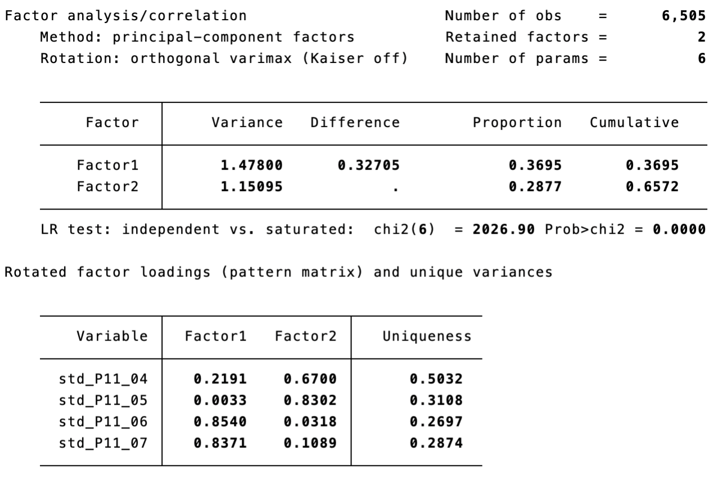

Variables used:

P11_04. Politics is ultimately a struggle between good and evil

P11_05. The will of the majority should always prevail, even over the rights of minorities

P11_06. [Country] is pretty much run by a few big interests looking out for themselves

P11_07. Politicians constantly over-complicate simple matters instead of effectively solving them

The four populism indicators, following the application of Principal Component Analysis (PCA), form two distinct factors. The first can be labeled as *Manichean (Dummy) Majoritarianism* (Factor 1)*,* and the second as  *Anti-Elitist Simplicism* (Factor 2). The scale reliability coefficient here is .49, and the proportion of variance explained by the factors is .37 and .29, respectively. Therefore, it can be argued that there are indeed two subtypes of populism.

A more detailed country by country analysis (see Table A1 the Appendix for details) unveils very similar pattern of two separate populist factors in Italy, France, Hungary and Poland (with less reliable scales – coefficient below 0.4 – in Italy and France). In Austria, Czechia and Great Britain these four items load on a single factor (with higher loadings of the Simplistic Anti-Elitism items) and most reliable scales in Austria (0.63) and Czechia (0.56).

In table 4 represented are – as the most adequate statistical analysis shows – three configurations indicative of **three types of illiberalism**.

**Table 4**. PCA of Illiberalism (all countries)

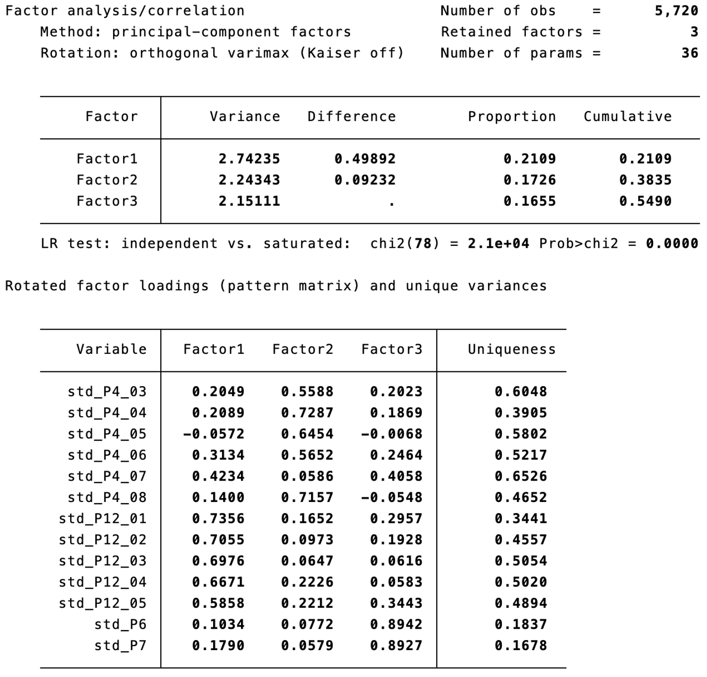

Variables:

P4_03. Women should be prepared to cut down on paid work for the sake of the family

P4_04. Same‐sex marriages should be prohibited by law

P4_05. Women should be free to decide on matters of abortion [Reversed]

P4_06. Teaching teenagers about tolerance towards transgender and homosexual minorities in schools can cause harm

P4_07. These days you cannot even say what you think about immigrants, women or gays without being called prejudiced

P4_08. Those who don't believe in God are not suitable for governing this country

P12_01. What our society needs is protection against international influences, not further opening up

P12_02. Leaders should always follow the interests of their country, even if this means going against international rules

P12_03. It is impossible for an organisation to serve the interests of our nation if most of its funding comes from foreign sources

P12_04. Those who claim that there are powerful organisations in the world which conspire against [Country] have a good point.

P12_05. These days the leading contribution white people have made to human culture is being downplayed

P6. Immigrants bad for the economy

P7. Immigrants bad for culture

The most clearly delineated type is *State Parochialist Illiberalism* (Factor 1), which combines several elements indicating a bundle of distrust in the external world, infused with state nationalism and coupled with conspiracy beliefs. In short, it represents a vision of an "autarkic" country isolated internationally, perceiving its surroundings as a threat.

The second type of illiberalism points to its socio-conservative variant, aptly named *Social Conservative Illiberalism* (Factor 2)*,* characterized by a syndrome of aversion and intolerance toward social diversity, infused with a vision of the traditional role of women.

Finally, the last variant of illiberalism is the widely discussed and staunchly defended phenomenon of *Nativism* (Factor 3).

The basic statistics of this analysis are highly statistically significant – the scale reliability coefficient is .82, and the proportion of variance explained for the three forms of illiberalism is .21, .17, and .17, respectively.

Considering cross-country differences (see Table A2 the Appendix for details), there is some heterogeneity which points to **variates of illiberalism in Europe**. The picture is very similar to the pooled analysis in Italy, Great Britain and Poland. In Czechia, there are also three main components in illiberalism, however they are conformed of different sets of items with a separate factor formed by the 'religious fundamentalism' item (P4_08) and the issue of abortion (P4_05), probably reflecting the idiosyncrasy of the highly secularized of Czech society. In Austria, there are only two factors, with nativist items loading well on the first factor of *State Parochialist Illiberalism* instead of conforming a separate factor as in the pooled analysis. In France and Hungary, there are four illiberal factors. In the former case, interestingly, attitudes on abortion load as a separate factor and nativism explains the highest proportion of the variation. In the latter one, it is political correctness (P4_07) that conforms a separate factor. The reliability of scales in all countries but France (0.77) is over 0.80.

Table 5 presents a complex picture regarding authoritarianism. If we were to adhere strictly to traditional statistical orthodoxy, which considers only configurations with an Eigenvalue above 1 as distinct factors, we would identify a single factor. This factor is a blend of social elements (such as socialization toward obedience and punitiveness) and attitudes directly related to the political sphere (such as the permissibility of law-bending by those in power and tolerance for a leader operating above the law).

It is worth noting that, in Table 2, these subtypes of authoritarianism were similarly structured, where we labeled them as *social authoritarianism* and *political (power-driven) authoritarianism,* respectively.

**Table 5**. PCA of Authoritarianism (all countries)

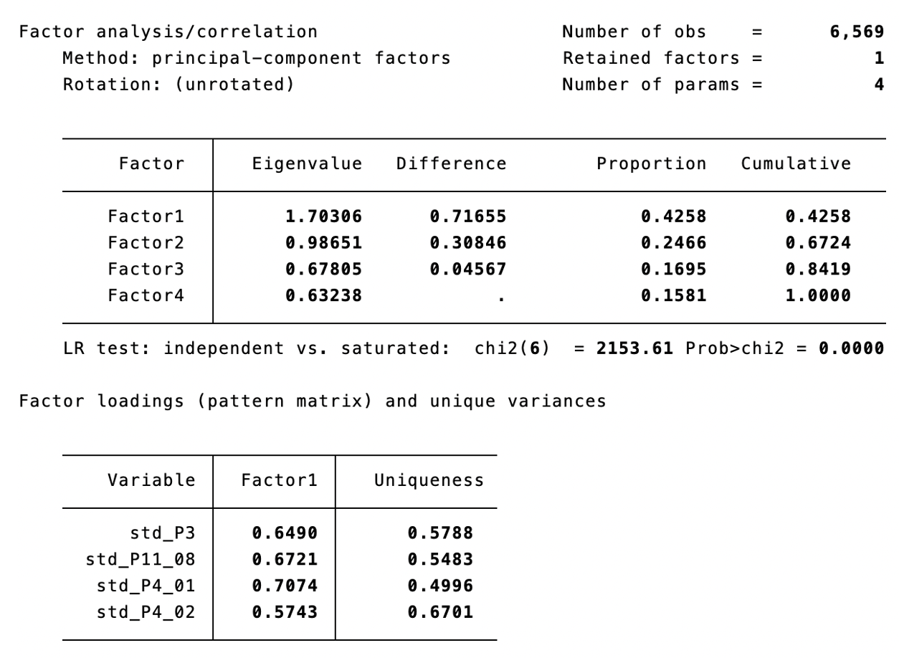

Variables:

P3. How acceptable for you would it be for the [Country] to have a strong leader who is above the law?

P11_08. The government should be able to bend the law in order to solve pressing social and political problems

P4_01. Obedience and respect for authority are the most important virtues children should learn

P4_02. People who break the law should be given much harsher sentences than they are these days

Given the second factor's Eigenvalue being close to the threshold (.99), we acknowledge the existence of two distinct forms of authoritarianism in this analysis as well.

Cross-country analysis confirms that the two-factor approach is reasonable (see Table A3 the Appendix for details). In four out of seven countries considered (France, Great Britain, Hungary and Poland) these items conform two factors in exactly the expected way: social authoritarianism and political (power-driven) authoritarianism. On the contrary, Italy, Austria and Czechia mirror the single-factor pooled image. The reliability of scales in all countries is between 0.41 (Poland) and 0.53 (Austria).

**(3) Vote Choice, Basic Socio-demographic Structure and the Intensity of Populist, Illiberal, and Authoritarian Attitudes (PIA)**

How are the PIA attitudes distributed among the electorates and basic social groups? Tables 6-12 shed light on this issue in a country-by-country comparison of mean values of the PIA latent variables (their standardized values) identified in the analysis of *core* PIA characteristics in Part 1 of the Results section. Needless to say, we expect to unveil a higher intensity of populist, illiberal and authoritarian attitudes among the followers of parties considered in the scholarly literature and among experts as radical right-wing ones. Moreover, assuming our data is reliable and worth in-depth analyses in the future, we anticipate that followers of other parties will similarly unveil plausible levels of PIA, for instance that voters of mainstream liberal/left/progressive parties will manifest lower Intensity. Moreover, we expect that education will be negatively associated with PIA, that older citizens will be more likely to hold PIA attitudes, and that (on average) males will show higher values of PIA. Two caveats before we delve into the data: in these analyses we use unweighted data and the factor scores of the latent PIA measures were computed for all of seven countries under scrutiny so the mean values reflect this grand mean rather than a country-specific mean in each case.

Starting with Poland (Table 6), PiS (Law and Justice) and Konfederacja (Confederation) supporters stand out as those with the highest mean values of PIA. Illiberal attitudes seem to be more widely shared by their voters, followed by the populist ones, and – although authoritarianism is less present among supporters of Konfederacja – PiS voters are on average significantly more likely to hold authoritarian values than voters of all other parties. On the other hand, New Left and Civic Coalition (KO) supporters on average score the lowest on all three PIA components. While there are no significant differences by age in populism, those aged 65 or older are significantly more illiberal and authoritarian (on average) than all younger age groups. Also men are significantly more likely to hold illiberal attitudes compared to women, but gender has no discriminatory power regarding populism and authoritarianism. Finally, as expected, higher education serves as a vaccine against authoritarian attitudes in Poland, but it does not seem to have significant association with the levels of populism. Poles with secondary education level are significantly more illiberal than their more educated counterpart.

**Table 6.** Mean values of PIA by vote choice, age, gender and education (**Poland**)

|  |  |  |  |  |  |  |  |  |  |  |  |  |
| --- | --- | --- | --- | --- | --- | --- | --- | --- | --- | --- | --- | --- |
|  | **Populism** | | | | **Illiberalism** | | | | **Authoritarianism** | | | |
|  | **Mean** | Std. err. | [95% conf. interval] | | **Mean** | Std. err. | [95% conf. interval] | | **Mean** | Std. err. | [95% conf. interval] | |
| **Vote choice** |  |  |  |  |  |  |  |  |  |  |  |  |
| New left | **-0.17** | 0.11 | -0.38 | 0.04 | **-0.45** | 0.10 | -0.64 | -0.25 | **-0.65** | 0.10 | -0.84 | -0.47 |
| KO | **-0.15** | 0.06 | -0.27 | -0.04 | **-0.29** | 0.05 | -0.40 | -0.18 | **-0.47** | 0.05 | -0.57 | -0.36 |
| Third Way | **0.00** | 0.09 | -0.18 | 0.18 | **0.12** | 0.08 | -0.04 | 0.29 | **-0.15** | 0.08 | -0.31 | 0.01 |
| PiS | **0.37** | 0.06 | 0.25 | 0.50 | **0.71** | 0.10 | 0.51 | 0.90 | **0.42** | 0.06 | 0.31 | 0.53 |
| Confederation | **0.54** | 0.11 | 0.33 | 0.76 | **0.75** | 0.06 | 0.63 | 0.86 | **0.15** | 0.10 | -0.04 | 0.33 |
| **Age** |  |  |  |  |  |  |  |  |  |  |  |  |
| 1. 18-24 | **0.07** | 0.11 | -0.15 | 0.29 | **-0.10** | 0.11 | -0.31 | 0.11 | **-0.30** | 0.10 | -0.50 | -0.10 |
| 2. 25-34 | **0.07** | 0.08 | -0.09 | 0.22 | **0.10** | 0.08 | -0.05 | 0.25 | **-0.13** | 0.07 | -0.28 | 0.01 |
| 3. 35-44 | **0.11** | 0.07 | -0.02 | 0.25 | **0.20** | 0.07 | 0.07 | 0.33 | **-0.10** | 0.06 | -0.23 | 0.03 |
| 4. 45-54 | **0.20** | 0.08 | 0.05 | 0.34 | **0.22** | 0.07 | 0.07 | 0.36 | **-0.13** | 0.07 | -0.27 | 0.01 |
| 5. 55-64 | **0.14** | 0.08 | -0.02 | 0.30 | **0.20** | 0.08 | 0.04 | 0.35 | **-0.15** | 0.08 | -0.30 | 0.00 |
| 6. 65+ | **0.22** | 0.06 | 0.09 | 0.34 | **0.52** | 0.06 | 0.39 | 0.64 | **0.32** | 0.06 | 0.20 | 0.43 |
| **Gender** |  |  |  |  |  |  |  |  |  |  |  |  |
| Female | **0.11** | 0.04 | 0.03 | 0.20 | **0.14** | 0.04 | 0.06 | 0.22 | **-0.09** | 0.04 | -0.17 | 0.00 |
| Male | **0.18** | 0.05 | 0.09 | 0.27 | **0.34** | 0.04 | 0.26 | 0.43 | **0.03** | 0.04 | -0.06 | 0.11 |
| **Education** |  |  |  |  |  |  |  |  |  |  |  |  |
| 1. Primary | **0.26** | 0.10 | 0.06 | 0.46 | **0.27** | 0.10 | 0.08 | 0.47 | **0.14** | 0.10 | -0.05 | 0.33 |
| 2. Secondary | **0.18** | 0.04 | 0.10 | 0.26 | **0.32** | 0.04 | 0.24 | 0.40 | **0.06** | 0.04 | -0.02 | 0.13 |
| 3. Tertiary | **0.04** | 0.06 | -0.07 | 0.15 | **0.07** | 0.05 | -0.04 | 0.18 | **-0.26** | 0.05 | -0.36 | -0.16 |

In Austria (Table 7), voters of FPÖ are the only ones holding high levels of PIA attitudes, significantly higher (on average) than those of supporters of all other parties. As in other countries, they score the highest on the measure of illiberalism. Regarding the socio-demographics: (1) those aged 55-64 are more likely to hold stronger populist and illiberal attitudes compared to those aged 25-34 and 65 or older, (2) men are significantly less authoritarian than women, and (3) only those with primary education hold PIA attitudes and both secondary and tertiary education levels significantly lower this prospect.

**Table 7.** Mean values of PIA by vote choice, age, gender and education (**Austria**)

|  |  |  |  |  |  |  |  |  |  |  |  |  |  |  |  |  |  |  |  |  |  |
| --- | --- | --- | --- | --- | --- | --- | --- | --- | --- | --- | --- | --- | --- | --- | --- | --- | --- | --- | --- | --- | --- |
|  | **Populism** | | | | | | | **Illiberalism** | | | | | | | **Authoritarianism** | | | | | | |
|  | | **Mean** | Std. err. | | | [95% conf. interval] | | | **Mean** | Std. err. | | | [95% conf. interval] | | | **Mean** | Std. err. | | | [95% conf. interval] | |
| **Vote choice** |  | | |  |  | |  |  | | |  |  | |  |  | | |  |  | |  |
| Grüne | **-0.69** | | | 0.10 | -0.88 | | -0.49 | **-1.13** | | | 0.09 | -1.31 | | -0.94 | **-1.09** | | | 0.09 | -1.27 | | -0.91 |
| JETZT | **-0.48** | | | 0.33 | -1.13 | | 0.16 | **-0.97** | | | 0.31 | -1.59 | | -0.35 | **-0.96** | | | 0.31 | -1.58 | | -0.35 |
| NEOS | **-0.29** | | | 0.16 | -0.60 | | 0.02 | **-0.60** | | | 0.15 | -0.90 | | -0.31 | **-0.58** | | | 0.15 | -0.87 | | -0.29 |
| SPÖ | **-0.29** | | | 0.08 | -0.45 | | -0.13 | **-0.49** | | | 0.08 | -0.64 | | -0.34 | **-0.44** | | | 0.08 | -0.59 | | -0.29 |
| ÖVP | **-0.17** | | | 0.07 | -0.31 | | -0.03 | **-0.02** | | | 0.07 | -0.15 | | 0.12 | **-0.01** | | | 0.07 | -0.14 | | 0.12 |
| FPÖ | **0.63** | | | 0.09 | 0.46 | | 0.80 | **0.72** | | | 0.08 | 0.56 | | 0.88 | **0.49** | | | 0.08 | 0.33 | | 0.65 |
| **Age** |  | | |  |  | |  |  | | |  |  | |  |  | | |  |  | |  |
| 0. 16-17 | **-0.29** | | | 0.32 | -0.92 | | 0.33 | **-0.85** | | | 0.32 | -1.48 | | -0.22 | **-0.31** | | | 0.32 | -0.93 | | 0.31 |
| 1. 18-24 | **-0.23** | | | 0.13 | -0.48 | | 0.03 | **-0.45** | | | 0.13 | -0.71 | | -0.20 | **-0.01** | | | 0.13 | -0.26 | | 0.24 |
| 2. 25-34 | **-0.24** | | | 0.09 | -0.43 | | -0.06 | **-0.28** | | | 0.10 | -0.47 | | -0.09 | **-0.23** | | | 0.09 | -0.41 | | -0.04 |
| 3. 35-44 | **-0.11** | | | 0.08 | -0.27 | | 0.06 | **-0.31** | | | 0.09 | -0.48 | | -0.15 | **-0.28** | | | 0.08 | -0.44 | | -0.11 |
| 4. 45-54 | **-0.03** | | | 0.08 | -0.19 | | 0.13 | **-0.04** | | | 0.08 | -0.2 | | 0.12 | **-0.10** | | | 0.08 | -0.26 | | 0.06 |
| 5. 55-64 | **0.13** | | | 0.08 | -0.02 | | 0.29 | **0.01** | | | 0.08 | -0.15 | | 0.17 | **-0.14** | | | 0.08 | -0.29 | | 0.02 |
| 6. 65+ | **-0.19** | | | 0.07 | -0.33 | | -0.05 | **-0.21** | | | 0.07 | -0.35 | | -0.07 | **-0.25** | | | 0.07 | -0.39 | | -0.11 |
| **Gender** |  | | |  |  | |  |  | | |  |  | |  |  | | |  |  | |  |
| Female | **-0.03** | | | 0.05 | -0.13 | | 0.07 | **-0.15** | | | 0.05 | -0.25 | | -0.05 | **-0.07** | | | 0.05 | -0.17 | | 0.02 |
| Male | **-0.15** | | | 0.05 | -0.24 | | -0.06 | **-0.22** | | | 0.05 | -0.31 | | -0.12 | **-0.28** | | | 0.05 | -0.37 | | -0.18 |
| **Education** |  | | |  |  | |  |  | | |  |  | |  |  | | |  |  | |  |
| 1. Primary | **0.22** | | | 0.07 | 0.08 | | 0.36 | **0.28** | | | 0.07 | 0.14 | | 0.42 | **0.38** | | | 0.07 | 0.24 | | 0.51 |
| 2. Secondary | **-0.06** | | | 0.05 | -0.17 | | 0.05 | **-0.19** | | | 0.06 | -0.30 | | -0.09 | **-0.21** | | | 0.05 | -0.32 | | -0.11 |
| 3. Tertiary | **-0.32** | | | 0.05 | -0.43 | | -0.21 | **-0.46** | | | 0.06 | -0.57 | | -0.35 | **-0.49** | | | 0.05 | -0.59 | | -0.38 |

The Hungarian case (Table 8) is particularly interesting due to the fact that Fidesz-KDNP is in power since 2010 and it is the only country in our sample that has been labeled by V-Dem as electoral autocracy. Thus, we expect that illiberal and authoritarian attitudes will be of more importance than the populist ones. Indeed, this assumption finds empirical support given that Fidesz supporters are the ones scoring lowest on populism (among voters of all parties), while their level of illiberal and authoritarian attitudes is the highest (together with Mi Hazánk voters, who also score high on populism). MKKP and DK-Jobbik-Momentum-MSZP-LMP voters are less likely to hold strong PIA attitudes, while supporters of Egyeb are somewhere in-between. Considering the socio-demographic variables, those aged 35-44 seem to be slightly more populist than the youngest (18-24) and the oldest (65+) age groups, but there are no significant age differences in the distribution of (average) illiberal nor authoritarian attitudes. Gender is also irrelevant in this case. Education does not discriminate on the level of populism, but the low educated, on average, hold stronger illiberal attitudes than the high educated, and all differences in means of authoritarianism among the three categories of education (primary, secondary, tertiary education) are significant, with education having a hindering effect.

**Table 8.** Mean values of PIA by vote choice, age, gender and education (**Hungary**)

|  |  |  |  |  |  |  |  |  |  |  |  |  |
| --- | --- | --- | --- | --- | --- | --- | --- | --- | --- | --- | --- | --- |
|  | **Populism** | | | | **Illiberalism** | | | | **Authoritarianism** | | | |
|  | **Mean** | Std. err. | [95% conf. interval] | | **Mean** | Std. err. | [95% conf. interval] | | **Mean** | Std. err. | [95% conf. interval] | |
| **Vote choice** |  |  |  |  |  |  |  |  |  |  |  |  |
| Fidesz-KDNP | **-0.38** | 0.06 | -0.49 | -0.27 | **0.40** | 0.05 | 0.30 | 0.51 | **0.40** | 0.06 | 0.29 | 0.52 |
| MKKP | **0.08** | 0.13 | -0.18 | 0.34 | **-0.76** | 0.13 | -1.02 | -0.51 | **-1.00** | 0.14 | -1.27 | -0.73 |
| DK-Jobbik-Momentum-MSZP-LMP | **0.12** | 0.06 | 0.00 | 0.25 | **-0.78** | 0.06 | -0.90 | -0.65 | **-0.93** | 0.06 | -1.05 | -0.80 |
| Egyeb | **0.21** | 0.09 | 0.04 | 0.38 | **-0.17** | 0.09 | -0.34 | 0.00 | **-0.28** | 0.09 | -0.46 | -0.10 |
| Mi Hazánk | **0.51** | 0.11 | 0.30 | 0.72 | **0.52** | 0.10 | 0.31 | 0.72 | **0.18** | 0.11 | -0.03 | 0.39 |
| **Age** |  |  |  |  |  |  |  |  |  |  |  |  |
| 1. 18-24 | **-0.28** | 0.11 | -0.50 | -0.06 | **-0.35** | 0.12 | -0.57 | -0.12 | **-0.29** | 0.12 | -0.53 | -0.05 |
| 2. 25-34 | **0.05** | 0.08 | -0.10 | 0.20 | **-0.19** | 0.08 | -0.35 | -0.04 | **-0.28** | 0.08 | -0.44 | -0.12 |
| 3. 35-44 | **0.07** | 0.07 | -0.07 | 0.20 | **-0.12** | 0.07 | -0.26 | 0.03 | **-0.24** | 0.08 | -0.39 | -0.09 |
| 4. 45-54 | **0.00** | 0.07 | -0.14 | 0.13 | **0.00** | 0.07 | -0.14 | 0.14 | **-0.11** | 0.07 | -0.25 | 0.04 |
| 5. 55-64 | **-0.06** | 0.08 | -0.22 | 0.09 | **-0.19** | 0.08 | -0.35 | -0.02 | **-0.34** | 0.09 | -0.52 | -0.17 |
| 6. 65+ | **-0.18** | 0.06 | -0.30 | -0.06 | **-0.03** | 0.06 | -0.15 | 0.10 | **-0.08** | 0.07 | -0.21 | 0.05 |
| **Gender** |  |  |  |  |  |  |  |  |  |  |  |  |
| Female | **-0.06** | 0.04 | -0.14 | 0.02 | **-0.09** | 0.04 | -0.17 | -0.01 | **-0.14** | 0.04 | -0.22 | -0.05 |
| Male | **-0.04** | 0.04 | -0.12 | 0.05 | **-0.13** | 0.05 | -0.23 | -0.04 | **-0.28** | 0.05 | -0.37 | -0.18 |
| **Education** |  |  |  |  |  |  |  |  |  |  |  |  |
| 1. Primary | **-0.18** | 0.07 | -0.32 | -0.03 | **0.13** | 0.08 | -0.02 | 0.28 | **0.18** | 0.08 | 0.02 | 0.33 |
| 2. Secondary | **-0.01** | 0.04 | -0.09 | 0.07 | **-0.07** | 0.04 | -0.15 | 0.01 | **-0.16** | 0.04 | -0.25 | -0.08 |
| 3. Tertiary | **-0.06** | 0.06 | -0.18 | 0.05 | **-0.34** | 0.06 | -0.45 | -0.22 | **-0.50** | 0.06 | -0.63 | -0.38 |

In Italy (Table 9), probably the most striking finding is the predominance of authoritarian attitudes among most electorates (only supporters of Alleanza Verdi e Sinistra and Democratico are below the grand mean of all seven countries). While voters of FdI, Lega, Forza Italia and M5S score high on authoritarianism, populism seems relevant only for the supporters of the latter party. Hence, as in Hungary, the ruling FdI’s supporters are not characterized by high levels of populist attitudes. Supporters of FdI (and Lega) do stand out as, on average, more illiberal than the other electorates. Regarding the socio-demographics, while there are no significant differences by age among mean values of populist and illiberal attitudes, the authoritarian ones seem to increase with age, with the oldest group having significantly higher values compared to the 25-34 years old category. As in the other countries, there is no gender gap in any of the PIA attitudes. Education on the other hand hinders PIA, with the tertiary educated being, on average, significantly less populist than the primary educated. The latter hold higher values of illiberal and authoritarian attitudes than the more educated.

**Table 9.** Mean values of PIA by vote choice, age, gender and education (**Italy**)

|  |  |  |  |  |  |  |  |  |  |  |  |  |
| --- | --- | --- | --- | --- | --- | --- | --- | --- | --- | --- | --- | --- |
|  | **Populism** | | | | **Illiberalism** | | | | **Authoritarianism** | | | |
|  | **Mean** | Std. err. | [95% conf. interval] | | **Mean** | Std. err. | [95% conf. interval] | | **Mean** | Std. err. | [95% conf. interval] | |
| **Vote choice** |  |  |  |  |  |  |  |  |  |  |  |  |
| Democratico | **-0.19** | 0.07 | -0.33 | -0.05 | **-0.62** | 0.07 | -0.76 | -0.49 | **-0.23** | 0.07 | -0.36 | -0.10 |
| Fratelli d’Italia | **-0.15** | 0.06 | -0.27 | -0.03 | **0.25** | 0.06 | 0.13 | 0.37 | **0.67** | 0.06 | 0.55 | 0.78 |
| Forza Italia | **-0.10** | 0.10 | -0.31 | 0.11 | **0.03** | 0.10 | -0.17 | 0.23 | **0.43** | 0.10 | 0.24 | 0.63 |
| Alleanza Verdi e Sinistra | **-0.09** | 0.15 | -0.38 | 0.21 | **-0.99** | 0.15 | -1.28 | -0.70 | **-0.70** | 0.14 | -0.98 | -0.41 |
| Lega Salvini Premier | **0.10** | 0.12 | -0.15 | 0.34 | **0.39** | 0.12 | 0.16 | 0.63 | **0.50** | 0.12 | 0.27 | 0.73 |
| Movimento 5 Stelle | **0.33** | 0.07 | 0.18 | 0.47 | **0.05** | 0.07 | -0.10 | 0.19 | **0.24** | 0.07 | 0.11 | 0.38 |
| **Age** |  |  |  |  |  |  |  |  |  |  |  |  |
| 1. 18-24 | **-0.09** | 0.12 | -0.32 | 0.14 | **-0.31** | 0.12 | -0.55 | -0.07 | **0.10** | 0.12 | -0.13 | 0.33 |
| 2. 25-34 | **-0.03** | 0.08 | -0.18 | 0.13 | **-0.24** | 0.08 | -0.40 | -0.08 | **0.05** | 0.08 | -0.11 | 0.20 |
| 3. 35-44 | **-0.01** | 0.07 | -0.15 | 0.13 | **-0.10** | 0.07 | -0.25 | 0.04 | **0.20** | 0.07 | 0.06 | 0.34 |
| 4. 45-54 | **0.07** | 0.06 | -0.06 | 0.19 | **-0.01** | 0.07 | -0.14 | 0.12 | **0.20** | 0.06 | 0.08 | 0.33 |
| 5. 55-64 | **0.03** | 0.07 | -0.10 | 0.16 | **-0.05** | 0.07 | -0.18 | 0.09 | **0.25** | 0.07 | 0.12 | 0.38 |
| 6. 65+ | **-0.12** | 0.06 | -0.24 | -0.01 | **-0.04** | 0.06 | -0.16 | 0.09 | **0.32** | 0.06 | 0.21 | 0.44 |
| **Gender** |  |  |  |  |  |  |  |  |  |  |  |  |
| Female | **0.00** | 0.04 | -0.07 | 0.08 | **-0.10** | 0.04 | -0.18 | -0.02 | **0.20** | 0.04 | 0.12 | 0.28 |
| Male | **-0.05** | 0.04 | -0.13 | 0.03 | **-0.07** | 0.04 | -0.16 | 0.01 | **0.23** | 0.04 | 0.14 | 0.31 |
| **Education** |  |  |  |  |  |  |  |  |  |  |  |  |
| 1. Primary | **0.13** | 0.07 | -0.02 | 0.27 | **0.21** | 0.08 | 0.06 | 0.36 | **0.47** | 0.07 | 0.32 | 0.62 |
| 2. Secondary | **-0.01** | 0.04 | -0.08 | 0.07 | **-0.12** | 0.04 | -0.20 | -0.04 | **0.19** | 0.04 | 0.12 | 0.27 |
| 3. Tertiary | **-0.13** | 0.06 | -0.24 | -0.02 | **-0.18** | 0.06 | -0.30 | -0.07 | **0.11** | 0.06 | 0.00 | 0.22 |

In the Czech case (Table 10), SPD is clearly the party with the most populist, illiberal, and, to less extend authoritarian electorate (on average). It is followed by a more heterogeneous but still holding over-the-mean levels of PIA attitudes electorate of the social democratic ČSSD and by supporters of ANO 2011. On the other hand, voters of Koalice Spolu and Piráti a Starostové are significantly less populist, illiberal and authoritarian compared to other parties’ supporters. Age is a stronger discriminant variable in Czechia, as those aged 55-64 hold significantly higher levels of populist attitudes then all other age groups, and the youngest group is also less populist compared to the 35-44 years old group. On the illiberalism scale the youngest groups (18-24 and 25-34) score significantly lower than the oldest ones (55-64 and 65+). Authoritarian attitudes seem to be distributed evenly across all age groups in Czechia. Gender is also irrelevant in this case. Those with highest education are on average less populist, illiberal and authoritarian than those with secondary education (and also primary in the case of authoritarianism).

**Table 10.** Mean values of PIA by vote choice, age, gender and education (**Czechia**)

|  |  |  |  |  |  |  |  |  |  |  |  |  |
| --- | --- | --- | --- | --- | --- | --- | --- | --- | --- | --- | --- | --- |
|  | **Populism** | | | | **Illiberalism** | | | | **Authoritarianism** | | | |
|  | **Mean** | Std. err. | [95% conf. interval] | | **Mean** | Std. err. | [95% conf. interval] | | **Mean** | Std. err. | [95% conf. interval] | |
| **Vote choice** |  |  |  |  |  |  |  |  |  |  |  |  |
| Koalice Spolu | **-0.60** | 0.08 | -0.75 | -0.44 | **-0.48** | 0.07 | -0.62 | -0.34 | **-0.49** | 0.07 | -0.63 | -0.35 |
| Piráti a Starostové | **-0.42** | 0.09 | -0.61 | -0.24 | **-0.64** | 0.09 | -0.80 | -0.47 | **-0.57** | 0.08 | -0.74 | -0.40 |
| ANO 2011 | **0.31** | 0.06 | 0.19 | 0.44 | **0.37** | 0.06 | 0.26 | 0.48 | **0.23** | 0.06 | 0.12 | 0.34 |
| ČSSD | **0.37** | 0.18 | 0.02 | 0.72 | **0.33** | 0.16 | 0.01 | 0.65 | **0.17** | 0.16 | -0.15 | 0.48 |
| SPD | **0.75** | 0.11 | 0.53 | 0.97 | **0.79** | 0.10 | 0.59 | 0.99 | **0.33** | 0.10 | 0.13 | 0.53 |
| **Age** |  |  |  |  |  |  |  |  |  |  |  |  |
| 1. 18-24 | **-0.30** | 0.11 | -0.51 | -0.09 | **-0.22** | 0.10 | -0.41 | -0.02 | **-0.08** | 0.10 | -0.27 | 0.11 |
| 2. 25-34 | **-0.16** | 0.09 | -0.32 | 0.01 | **-0.11** | 0.08 | -0.27 | 0.04 | **-0.06** | 0.08 | -0.22 | 0.09 |
| 3. 35-44 | **0.10** | 0.08 | -0.05 | 0.25 | **0.09** | 0.07 | -0.05 | 0.23 | **-0.06** | 0.07 | -0.20 | 0.07 |
| 4. 45-54 | **-0.01** | 0.07 | -0.15 | 0.14 | **0.04** | 0.07 | -0.10 | 0.18 | **-0.06** | 0.07 | -0.20 | 0.07 |
| 5. 55-64 | **0.43** | 0.09 | 0.26 | 0.60 | **0.30** | 0.08 | 0.14 | 0.46 | **-0.04** | 0.08 | -0.20 | 0.11 |
| 6. 65+ | **0.12** | 0.06 | -0.01 | 0.24 | **0.25** | 0.06 | 0.14 | 0.37 | **0.11** | 0.06 | -0.01 | 0.22 |
| **Gender** |  |  |  |  |  |  |  |  |  |  |  |  |
| Female | **0.11** | 0.05 | 0.02 | 0.20 | **0.12** | 0.04 | 0.03 | 0.20 | **0.04** | 0.04 | -0.04 | 0.12 |
| Male | **0.01** | 0.05 | -0.08 | 0.11 | **0.08** | 0.04 | -0.01 | 0.16 | **-0.08** | 0.04 | -0.16 | 0.01 |
| **Education** |  |  |  |  |  |  |  |  |  |  |  |  |
| 1. Primary | **-0.01** | 0.13 | -0.27 | 0.25 | **0.09** | 0.12 | -0.15 | 0.33 | **0.20** | 0.12 | -0.03 | 0.43 |
| 2. Secondary | **0.22** | 0.04 | 0.14 | 0.30 | **0.24** | 0.04 | 0.16 | 0.31 | **0.10** | 0.04 | 0.03 | 0.17 |
| 3. Tertiary | **-0.26** | 0.06 | -0.38 | -0.15 | **-0.20** | 0.05 | -0.31 | -0.10 | **-0.30** | 0.05 | -0.41 | -0.20 |

For France (Table 11), according to the reported vote choice in the recent Legislative Elections (1st round, June 30, 2024), Rassemblement Nationale (RN) stands out as the party with voters scoring high on PIA (significant differences with voters of all other parties, a part from Les Républicains and Reconquête scoring high also on the authoritarian scale). Ensemble and Nouveau Front Populaire stand out as parties with electorates with lowest levels of PIA. We find no significant differences in levels of PIA by age nor gender in France. Those with tertiary education are, on average, significantly less populist, illiberal and authoritarian than those with secondary level (but not primary).

**Table 11.** Mean values of PIA by vote choice, age, gender and education (**France**)

|  |  |  |  |  |  |  |  |  |  |  |  |  |
| --- | --- | --- | --- | --- | --- | --- | --- | --- | --- | --- | --- | --- |
|  | **Populism** | | | | **Illiberalism** | | | | **Authoritarianism** | | | |
|  | **Mean** | Std. err. | [95% conf. interval] | | **Mean** | Std. err. | [95% conf. interval] | | **Mean** | Std. err. | [95% conf. interval] | |
| **Vote choice** |  |  |  |  |  |  |  |  |  |  |  |  |
| Reconq. | **-0.72** | 0.26 | -1.24 | -0.20 | **0.05** | 0.23 | -0.41 | 0.51 | **0.32** | 0.23 | -0.13 | 0.78 |
| Ensemble | **-0.46** | 0.08 | -0.62 | -0.30 | **-0.43** | 0.07 | -0.58 | -0.28 | **-0.02** | 0.07 | -0.16 | 0.12 |
| Les Républic. | **-0.24** | 0.12 | -0.49 | 0.00 | **0.10** | 0.11 | -0.12 | 0.32 | **0.38** | 0.11 | 0.16 | 0.59 |
| Nouveau Front Populaire | **-0.17** | 0.06 | -0.29 | -0.05 | **-0.39** | 0.06 | -0.50 | -0.29 | **-0.23** | 0.06 | -0.34 | -0.12 |
| RN | **0.34** | 0.05 | 0.24 | 0.45 | **0.50** | 0.05 | 0.41 | 0.59 | **0.61** | 0.05 | 0.52 | 0.70 |
| **Age** |  |  |  |  |  |  |  |  |  |  |  |  |
| 1. 18-24 | **-0.22** | 0.11 | -0.43 | -0.01 | **-0.11** | 0.10 | -0.30 | 0.08 | **0.22** | 0.10 | 0.03 | 0.41 |
| 2. 25-34 | **-0.09** | 0.09 | -0.27 | 0.09 | **0.14** | 0.08 | -0.03 | 0.30 | **0.28** | 0.08 | 0.12 | 0.44 |
| 3. 35-44 | **-0.05** | 0.07 | -0.19 | 0.10 | **-0.04** | 0.07 | -0.18 | 0.09 | **0.12** | 0.07 | -0.02 | 0.25 |
| 4. 45-54 | **0.12** | 0.07 | -0.02 | 0.27 | **0.13** | 0.07 | -0.01 | 0.26 | **0.24** | 0.07 | 0.11 | 0.38 |
| 5. 55-64 | **0.05** | 0.07 | -0.10 | 0.20 | **0.08** | 0.07 | -0.06 | 0.21 | **0.35** | 0.07 | 0.21 | 0.48 |
| 6. 65+ | **0.07** | 0.06 | -0.05 | 0.19 | **0.08** | 0.06 | -0.03 | 0.19 | **0.28** | 0.06 | 0.17 | 0.39 |
| **Gender** |  |  |  |  |  |  |  |  |  |  |  |  |
| Female | **0.04** | 0.04 | -0.04 | 0.12 | **0.09** | 0.04 | 0.02 | 0.16 | **0.31** | 0.04 | 0.23 | 0.38 |
| Male | **-0.03** | 0.05 | -0.12 | 0.07 | **0.01** | 0.04 | -0.08 | 0.10 | **0.17** | 0.04 | 0.09 | 0.26 |
| **Education** |  |  |  |  |  |  |  |  |  |  |  |  |
| 1. Primary | **-0.04** | 0.12 | -0.27 | 0.19 | **0.08** | 0.11 | -0.13 | 0.29 | **0.37** | 0.11 | 0.16 | 0.58 |
| 2. Secondary | **0.17** | 0.04 | 0.08 | 0.26 | **0.20** | 0.04 | 0.12 | 0.28 | **0.39** | 0.04 | 0.31 | 0.47 |
| 3. Tertiary | **-0.15** | 0.05 | -0.24 | -0.06 | **-0.11** | 0.04 | -0.19 | -0.02 | **0.08** | 0.04 | 0.00 | 0.16 |

In Great Britain, always according to the reported vote choice in the last General Election of July 4th 2024, the Reform UK party stands out as the party whose voters score high on PIA attitudes. Significantly higher than voters of all other parties but the Conservatives who also score high on authoritarianism. Regarding age differences, the only significant one is between the youngest and the oldest group in that the latter hold more illiberal attitudes. Gender is non-significant and tertiary education always means lower levels of PIA attitudes compared to both primary and secondary education levels.

**Table 12.** Mean values of PIA by vote choice, age, gender and education (**Great Britain**)

|  |  |  |  |  |  |  |  |  |  |  |  |  |
| --- | --- | --- | --- | --- | --- | --- | --- | --- | --- | --- | --- | --- |
|  | **Populism** | | | | **Illiberalism** | | | | **Authoritarianism** | | | |
|  | **Mean** | Std. err. | [95% conf. interval] | | **Mean** | Std. err. | [95% conf. interval] | | **Mean** | Std. err. | [95% conf. interval] | |
| **Vote choice** |  |  |  |  |  |  |  |  |  |  |  |  |
| Conservative | **-0.20** | 0.07 | -0.34 | -0.06 | **0.23** | 0.07 | 0.10 | 0.37 | **0.27** | 0.07 | 0.12 | 0.41 |
| Liberal Democrat | **-0.20** | 0.10 | -0.40 | 0.01 | **-0.39** | 0.10 | -0.59 | -0.19 | **-0.45** | 0.11 | -0.66 | -0.24 |
| Labour | **-0.10** | 0.05 | -0.19 | -0.01 | **-0.11** | 0.05 | -0.20 | -0.02 | **-0.09** | 0.05 | -0.19 | 0.00 |
| Green Party | **0.08** | 0.14 | -0.19 | 0.36 | **-0.66** | 0.14 | -0.93 | -0.39 | **-0.89** | 0.14 | -1.17 | -0.60 |
| Reform UK | **0.61** | 0.09 | 0.43 | 0.78 | **0.75** | 0.09 | 0.57 | 0.92 | **0.38** | 0.09 | 0.19 | 0.56 |
| **Age** |  |  |  |  |  |  |  |  |  |  |  |  |
| 1. 18-24 | **-0.16** | 0.11 | -0.37 | 0.06 | **-0.29** | 0.11 | -0.51 | -0.07 | **-0.25** | 0.12 | -0.48 | -0.02 |
| 2. 25-34 | **-0.11** | 0.08 | -0.27 | 0.04 | **0.03** | 0.08 | -0.13 | 0.18 | **0.10** | 0.08 | -0.06 | 0.26 |
| 3. 35-44 | **0.02** | 0.07 | -0.13 | 0.16 | **0.00** | 0.08 | -0.15 | 0.15 | **-0.05** | 0.08 | -0.21 | 0.10 |
| 4. 45-54 | **0.03** | 0.07 | -0.11 | 0.16 | **-0.03** | 0.07 | -0.17 | 0.11 | **-0.01** | 0.07 | -0.15 | 0.13 |
| 5. 55-64 | **-0.06** | 0.07 | -0.19 | 0.08 | **-0.10** | 0.07 | -0.24 | 0.05 | **-0.14** | 0.07 | -0.29 | 0.00 |
| 6. 65+ | **-0.05** | 0.06 | -0.17 | 0.06 | **0.16** | 0.06 | 0.04 | 0.27 | **0.06** | 0.06 | -0.06 | 0.18 |
| **Gender** |  |  |  |  |  |  |  |  |  |  |  |  |
| Female | **-0.07** | 0.04 | -0.15 | 0.00 | **-0.04** | 0.04 | -0.12 | 0.04 | **-0.02** | 0.04 | -0.10 | 0.06 |
| Male | **-0.01** | 0.05 | -0.11 | 0.08 | **0.06** | 0.05 | -0.04 | 0.15 | **-0.01** | 0.05 | -0.11 | 0.09 |
| **Education** |  |  |  |  |  |  |  |  |  |  |  |  |
| 1. Primary | **0.13** | 0.09 | -0.05 | 0.31 | **0.26** | 0.09 | 0.07 | 0.44 | **0.14** | 0.10 | -0.05 | 0.33 |
| 2. Secondary | **0.04** | 0.04 | -0.05 | 0.12 | **0.08** | 0.04 | 0.00 | 0.17 | **0.09** | 0.05 | -0.01 | 0.18 |
| 3. Tertiary | **-0.17** | 0.04 | -0.25 | -0.08 | **-0.15** | 0.05 | -0.24 | -0.06 | **-0.18** | 0.05 | -0.27 | -0.09 |

In sum, the detailed country-by-country analyses sketch the following general picture. First, in all seven countries, the followers of the recognized radical right parties – PiS and Konfederacja in Poland, FPÖ in Austria, Fidesz in Hungary, FdI and Lega in Italy, SPD in Czechia, RN in France, and Reform UK in Great Britain – display clearly and significantly higher levels of illiberal and authoritarian attitudes. However, when it comes to populist attitudes, the ruling Fidesz and FdI stand out as parties with the least populist voters on average, showcasing the complex adaptation of theories of populism to actors in power. On the other hand, supporters of liberal and left parties score significantly lower on PIA attitudes in all countries considered.

Regarding the basic socio-demographic characteristics, the older age groups (but not always the oldest) seem to be, on average, more populist, illiberal and authoritarian than particularly the youngest groups, who hold less authoritarian (and definitely less illiberal) attitudes that one might expect from the literature on cohort-based decrease in support for democracy (Foa and Munk 2016). Also, the widely discussed gender gap in support for the radical right parties does not find support at the attitudinal PIA level. It remains to be seen whether these attitudes translate differently by age and gender into voting behaviour. As for education, this analysis confirms that tertiary education serves as a vaccine against high levels of PIA attitudes. However, it is among those with secondary education (and not primary) where these attitudes find greatest representation.

Taken together, high levels of illiberal attitudes seem to be the ones most widely shared, while populist attitudes appear as less relevant. The authoritarian ones are worryingly high among various socio-political groups in Italy and France and, to a lesser degree, in Czechia.

**(4) Normative Visions of Democracy and the Intensity of Populist, Illiberal, and Authoritarian Attitudes (PIA)**

Citizens of the European Union hold diverse views on key aspects of their political culture and order, as well as on specific components of their political systems, including democracy. The European Social Survey (Module 10, conducted in 2021/22) reveals considerable variation in citizens' preferences regarding normative visions of democracy. In other words, EU citizens have differing expectations of democracy, and the study identified four ideal-typical models of democracy: liberal, social-democratic, direct, and populist. The order in which these models are listed also reflects their prevalence—nearly all Europeans expect their democracy to meet the requirements of the liberal model, while significantly smaller proportions favor the other three models. Of these, the least "popular" model is populist democracy (Ferrin, Kriesi 2016; 2024).

For the purposes of our analysis, we will focus on only two of these models—the liberal and populist models. Each model consists of three indicators, with their precise operationalization detailed in the section on "Operationalization." It is important to emphasize that the three variables used to construct the normative visions of liberal and populist democracy are simple additive indices and are not derived from factor analysis or any other such method (see Table A4 in the Appendix for correlations between single items and PIA factors identified in part 2 of the analysis). Moreover, since the majority of Europeans support both models of democracy to varying degrees, we had to make a somewhat arbitrary decision to classify as supporters of the liberal model all individuals who, by one degree (on an eleven-point scale), favor the liberal model over the populist model. Conversely, supporters of the populist model were classified in the same manner. In our sample, 37% were identified as supporters of the liberal model, 15% as supporters of the populist model, while 48% fell into the mixed category, consisting of individuals whose preferences for one model over the other were not sufficiently large to assign them to either category.

**Tables 13**. Average intensity of populist, illiberal, and authoritarian attitudes across the three categories distinguished by the two visions of democracy.

|  |  |  |  |  |  |  |
| --- | --- | --- | --- | --- | --- | --- |
|  | Populist attitudes | | Illiberal attitudes | | Authoritarian attitudes | |
| Vision of democracy | Mean | Std. error | Mean | Std. error | Mean | Std. error |
| Liberal model | -0,07 | 0,00 | -0,28 | 0,02 | -0,36 | 0,03 |
| Populist model | 0,10 | 0,01 | 0,41 | 0,02 | 0,54 | 0,04 |
| Indifferent | 0,02 | 0,00 | 0,07 | 0,01 | 0,15 | 0,03 |
| Prob<F | 0,000 |  | 0,000 |  | 0,000 |  |
| Adj-R squared | 0,055 |  | 0,09 |  | 0,04 |  |

It is worth discussing these results collectively. The most general and essential finding is that, in all three cases, supporters of the populist vision of democracy exhibit stronger PIA (populist, illiberal, and authoritarian) attitudes than undecided respondents, who, in turn, show stronger PIA attitudes than supporters of the liberal model. This suggests a universal phenomenon, indicating that our collected data are methodologically sound, consistent, and logically coherent.

However, when examining the specifics of these distributions, two narratives emerge. The first, based on the R² coefficient (indicating the amount of explained variance), shows that illiberalism is most strongly differentiated by normative preferences regarding models of democracy. The second narrative reveals that the absolute differences in mean values between supporters of the populist and liberal models are most significant for authoritarianism and relatively negligible for populism. This apparent discrepancy arises from the varying degrees of homogeneity within the groups of supporters for each model of democracy. The internal consistency (as indicated by the standard errors) is lowest for the intensity of populism and highest for authoritarianism.

Put differently, authoritarianism among our respondents is the most randomly distributed across supporters of different models of democracy, while populism is the least. This can be (somewhat speculatively) interpreted to suggest that authoritarianism is the most antagonistic to democracy in general (whether liberal or otherwise), whereas populism, according to some scholars and theorists (Mair 2002; Urbinati 2019), may not necessarily contradict the classical requirements of democracy. Some even refer to it as "popular democracy" (Mair 2002).

**Conclusions**

1) Based on our empirical evidence and the analytical framework employed, it is evident that our findings reflect a rigorously curated dataset. The distribution of variables and the observed relationships are consistent, theoretically coherent, and methodologically sound, reinforcing the robustness of our analysis.

2) Our theoretical premises regarding the three categories of illiberal attitudes—populism, illiberalism, and authoritarianism—have been empirically substantiated in both analytical approaches. One analysis directly tested the conceptual validity of these distinct phenomena, while the other employed a more inductive approach to uncover varying configurations and interactions among them.

3) Through the empirical-inductive analysis, we identified seven distinct subtypes of non-liberal syndromes—two linked to populism, two to authoritarianism, and three to illiberalism. These subtypes, as well as the broader typological differentiation, align closely with existing theoretical frameworks and the substantive logic underpinning the operationalization of the variables. Importantly, this classification does not preclude the possibility of overlapping configurations where indicators of populism, illiberalism, and authoritarianism (PIA) converge across subtypes or within the broader categories themselves.

4) Nevertheless, it is critical to emphasize the cross-national variations identified in our findings. These disparities are neither arbitrary or random nor illogical but reflect context-specific dynamics that warrant further scholarly inquiry, which falls beyond the scope of the current study.

5) From the analysis of the distribution of intensity of populist, illiberal and authoritarian attitudes across different socio-demographic groups and by party electorates some key findings stand out. First, high levels of illiberal attitudes seem to be a characteristic shared more widely than the populist and authoritarian ones, although the latter are also widespread among populations of Italy, France and Czechia. Second, there is a lot of variation in the distribution of levels of PIA attitudes, confirming that some electorates or groups are, e.g. not populist at all , but highly illiberal, and – simultaneously - hold average level authoritarian attitudes. In other words, high P does necessarily mean high I and high A across different groups. This is particularly true for the populist radical right parties in power (Fidesz in Hungary and FdI in Italy). Third, while we found no significant gender gap in levels of PIA, the results confirm that age is usually positively correlated with levels of PIA (with some notable exceptions) and that tertiary education serves as a vaccine against PIA (with those with secondary education – and not primary – where these attitudes find greatest representation). Forth, our key assumption that the three concepts and phenomena (PIA) are separate but correlated has been confirmed. The results clearly reveal three distinct levels of anti-liberalism. Populism represents the mildest and most moderate challenge to liberal values, illiberalism poses more serious threats, and authoritarianism is not only anti-liberal but also an outright anti-democratic ideology. For a significant part of society to move from high levels of populism—often observed when opposition parties are vying for office—to more widespread illiberal, and eventually authoritarian, beliefs, takes time. Furthermore, populism, as an anti-elitist phenomenon, is less pronounced in countries where anti-liberal forces have held power for a considerable period, such as Hungary and Italy.

6) Finally, and we consider these findings highly consequential, citizens across the seven countries demonstrate divergent expectations of democracy, reflecting distinct normative preferences. Our analysis concentrated on two democratic models—liberal and populist. The results once again affirm the robustness of the data and the validity of the relationships between citizens who favor either the liberal or populist model. In the latter case, we observe a markedly higher prevalence of populist, illiberal, and authoritarian orientations.

# **References:**

Alizada N, Cole R, Gastaldi L, et al. (2021). Democracy report 2021: autocratization turns viral. University of Gothenburg: V-Dem Institute.

Bogaards, M. (2009). "How to classify hybrid regimes? Defective democracy and electoral authoritarianism." Democratization 16.2: 399-423.

Blokker, P. (2021). “Populism and illiberalism.” In *Routledge Handbook of Illiberalism* (pp.261-279). Routledge.

Bustikova, L. & Guasti, P. (2018). The State as a Firm: Understanding the Autocratic Roots of Technocratic [Populism](https://www.populismstudies.org/Vocabulary/populism/). *East European Politics and Societies: and Cultures*. 088832541879172. 10.1177/0888325418791723.

Castanho Silva, Bruno, Ioannis Andreadis, Eva Anduiza, Nebojša Blanuša, Yazmin Morlet Corti, Gisela Delfino, Guillem Rico, et al. (2018). “Public Opinion Surveys: A New Scale.” In *The Ideational Approach to Populism: Theory, Method & Analysis*, edited by Kirk Hawkins, Ryan Carlin, Levente Littvay, and Cristóbal Rovira Kaltwasser, 150-178. London: Routledge.

De Vries, C. E., 'What Is the Matter with Europe? The Puzzles of Euroscepticism', *Euroscepticism and the Future of European Integration* (Oxford, 2018; online edn, Oxford Academic, 18 Jan. 2018), <https://doi.org/10.1093/oso/9780198793380.003.0002>,.

Diamond, L. (2002). “Elections Without Democracy: Thinking About Hybrid Regimes.” *Journal of Democracy* 13(2), 21-35. doi:10.1353/jod.2002.0025

Enyedi, Z. (2015). Paternalist populism and illiberal elitism in Central Europe. *Journal of Political Ideologies*, *21*(1), 9–25. <https://doi.org/10.1080/13569317.2016.1105402>

Enyedi, Z. (2024). “Concept and Varieties of Illiberalism.” *Politics and Governance* vol.12, DOI: <https://doi.org/10.17645/pag.8521>

Erdmann, G. (2011). “Transition from Democracy. Loss of Quality, Hybridisation and Breakdown of Democracy.” *GIGA WP* 161/2011.

Ferrín, M., & Kriesi, H. (2016). *How Europeans view and evaluate democracy*. Oxford University Press.

Ferrín, M., & Kriesi, H. (2024). *How Europeans view and evaluate democracy*. *Ten years after.* Oxford University Press.

Foa, R. S., & Mounk, Y. (2016). The danger of deconsolidation: The democratic disconnect. *Journal of Democracy*, 27(3), 5-17.

Glasius, M. (2018). “What authoritarianism is… and is not: a practice perspective.” *International Affairs* 94(3), 515-533.

Hawkins, Kirk A. (2009). “Is Chavez Populist?: Measuring Populist Discourse in Comparative Perspective.” *Comparative Political Studies* 42(8): 1040-1067

Laruelle, M. (2022). “Illiberalism: a conceptual introduction.” *East European Politics*, 38(2), 303-327.

Levitsky, S., & Way, L. A. (2002). “Elections without democracy: The rise of competitive authoritarianism.” *Journal of Democracy*, 13(2), 51-65.

Mair, P. (2002). Populist Democracy vs Party Democracy. In: Mény, Y., Surel, Y. (eds) Democracies and the Populist Challenge. Palgrave Macmillan, London. <https://doi.org/10.1057/9781403920072_5>

Markowski, R. & Kotnarowski, M. (2025). 'Alternatives to liberal democracies (ALDs) and their consolidation in Central and Eastern Europe', *Politics and Governance* (under review)

Markowski, R. (2003) ‘Populism, Illiberalism, Neo-Authoritarianism: On the Conceptual Labyrinth and the Ways Out’. Presented at the IPSA Congress, Buenos Aires, 2023.

Markowski, R., Zagorski, P., Zerkowska-Balas, M., Stanley, B., Enyedi, Z., Mikola, B., Rovny, J., Whitefield, S., & Vukovic, M. (2023). *Literature review: Illiberalism, authoritarianism and populism (D2.1 deliverable for the AUTHLIB project)*. Deliverable 1.2 for the AUTHLIB Project.

Markowski, Radoslaw. ‘Creating Authoritarian Clientelism: Poland After 2015’. *Hague Journal on the Rule of Law* 11, no. 1 (April 2019): 111–32. <https://doi.org/10.1007/s40803-> 018-0082-5.

Merkel, Wolfgang. (2004). ‘Embedded and Defective Democracies’. *Democratization* 11(5): 33– 58.

Mudde, C. (2004). “The populist zeitgeist.” *Government and Opposition*, 39(4), 541-563.

Pappas, T. S. (2016). “Are populist leaders “charismatic”? The evidence from Europe.” *Constellations*, 23(3), 378-390.

Pirro, A.L.P., Stanley, Ben (2022). "Forging, Bending, and Breaking: Enacting the 'Illiberal Playbook' in Hungary and Poland". *perspectives on Politics,* 20 (1): 86-101

Schedler, A. (2015). “Electoral Authoritarianism.” In: *Emerging Trends in the Social and Behavioral Sciences* (eds R.A. Scott and S.M. Kosslyn). <https://doi.org/10.1002/9781118900772.etrds0098>.

Stanley, B. (2008). “The thin ideology of populism.” *Journal of Political Ideologies*, 13(1), 95-110.

Svolik, M.W. (2019). “Polarization versus Democracy.” *Journal of Democracy* 30(3), 20- 32. [doi:10.1353/jod.2019.0039.](http://doi.org/10.1353/jod.2019.0039)

Urbinati, N. (2019). *Me the people: How populism transforms democracy*. Harvard University Press.

Vachudova, M. (2020). Ethnopopulism and democratic backsliding in Central Europe. *East European Politics*, *36*(3), 318–340. <https://doi.org/10.1080/21599165.2020.1787163>

Varga, M., & Buzogány, A. (2022). “The two faces of the ‘global right’: revolutionary conservatives and national-conservatives.” *Critical Sociology*, 48(6), 1089-1107.

Wodak, R. (2019). “Entering the ‘post-shame era’: the rise of illiberal democracy, populism and neo-authoritarianism in EUrope." *Global Discourse*, vol 9, no 1., pp. 195-213. DOI: https://doi.org/10.1332/204378919X15470487645420

Zakaria, F. (1997). “The Rise of Illiberal Democracy.” *Foreign Affairs*, vol. 76, p. 22-43.

**Appendix**

**Table A1**. PCA of populism (country-by-country)

Variables used:

P11_04. Politics is ultimately a struggle between good and evil

P11_05. The will of the majority should always prevail, even over the rights of minorities

P11_06. [Country] is pretty much run by a few big interests looking out for themselves

P11_07. Politicians constantly over-complicate simple matters instead of effectively solving them

**Italy**

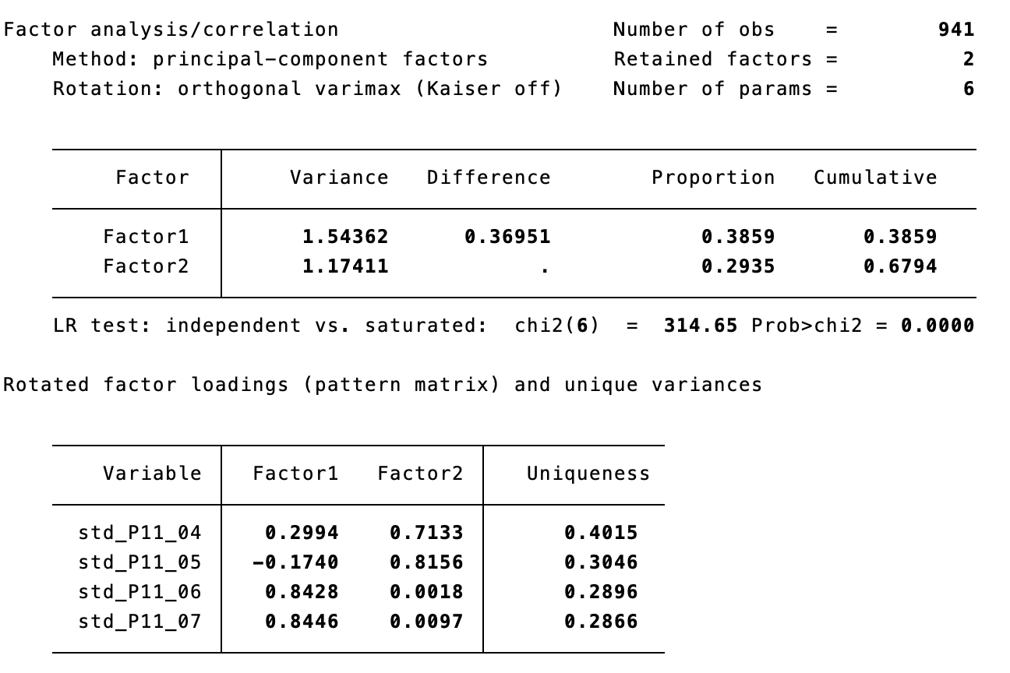

**Czechia**

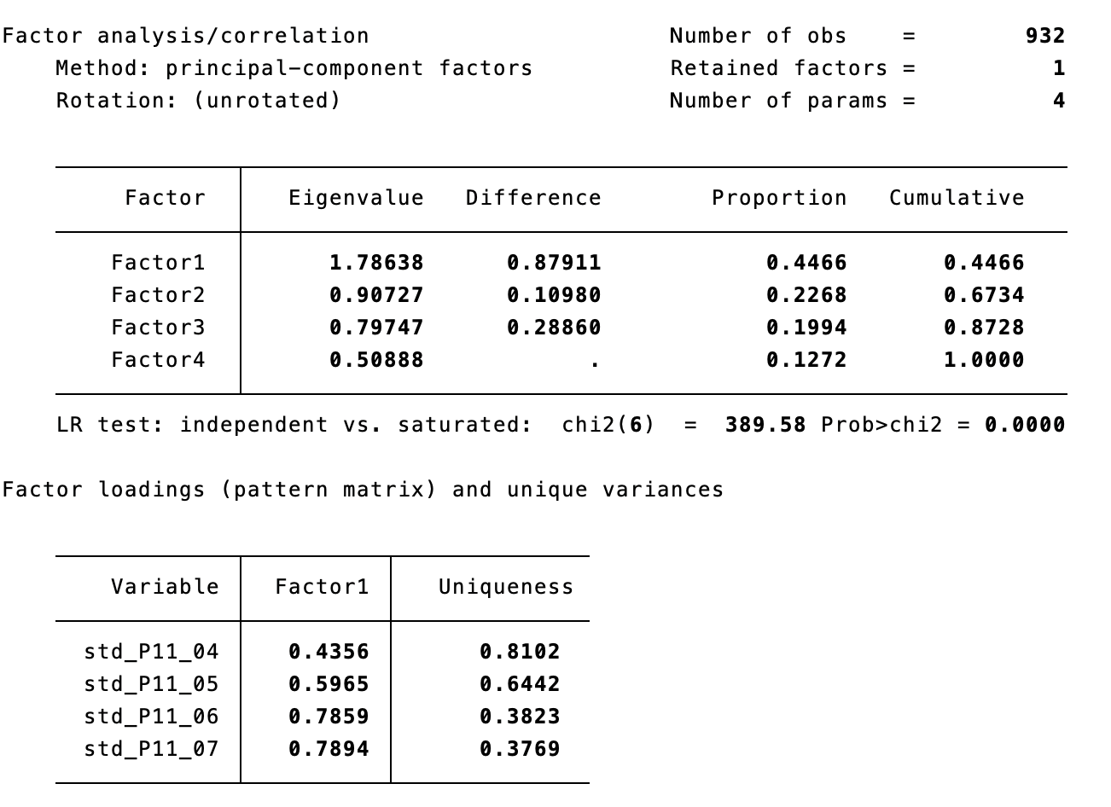

**Table A1** continued.

**Austria**

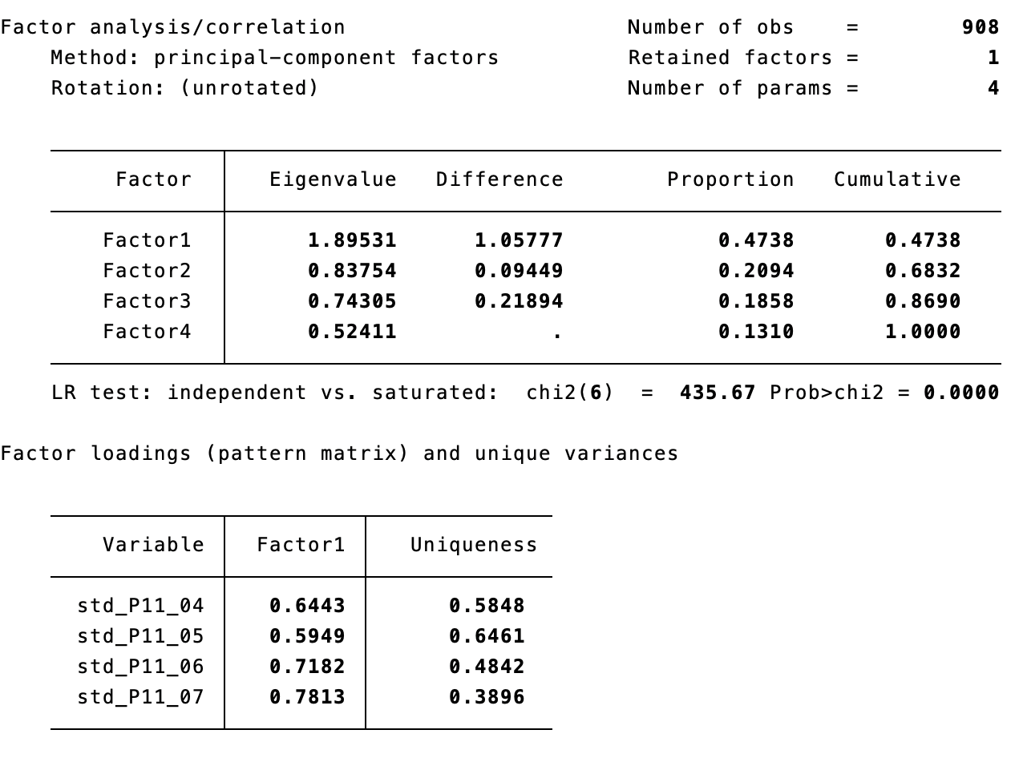

**France**

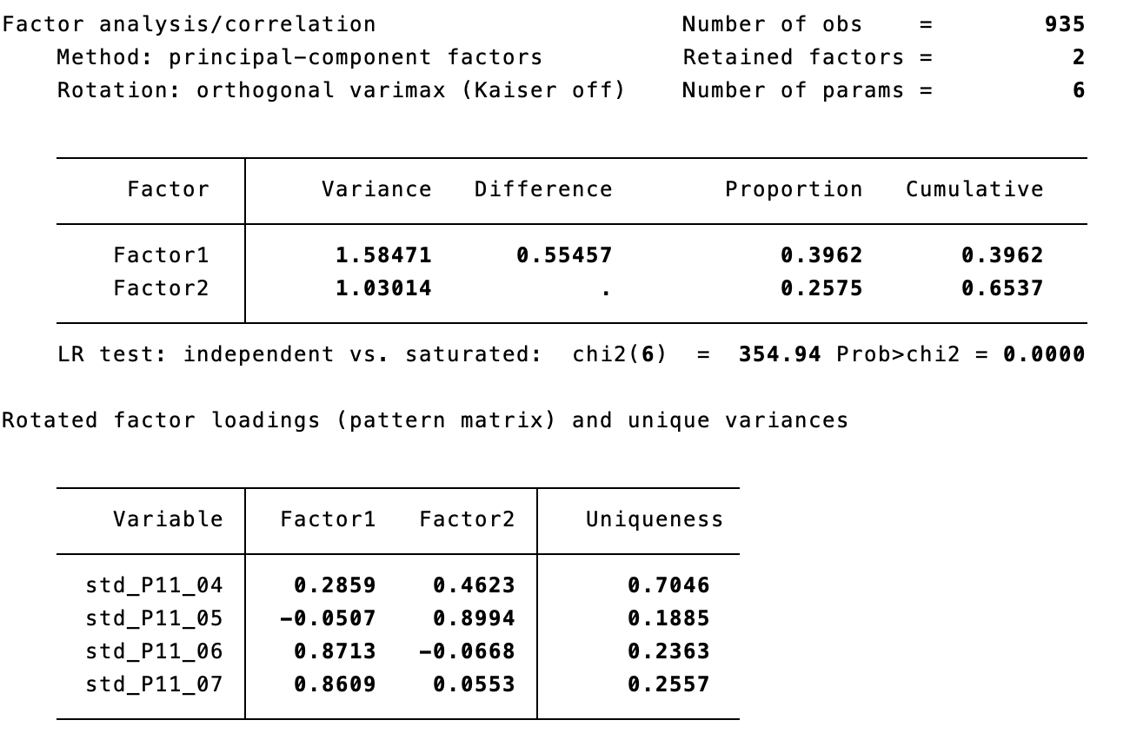

**Table A1** continued.

**Great Britain**

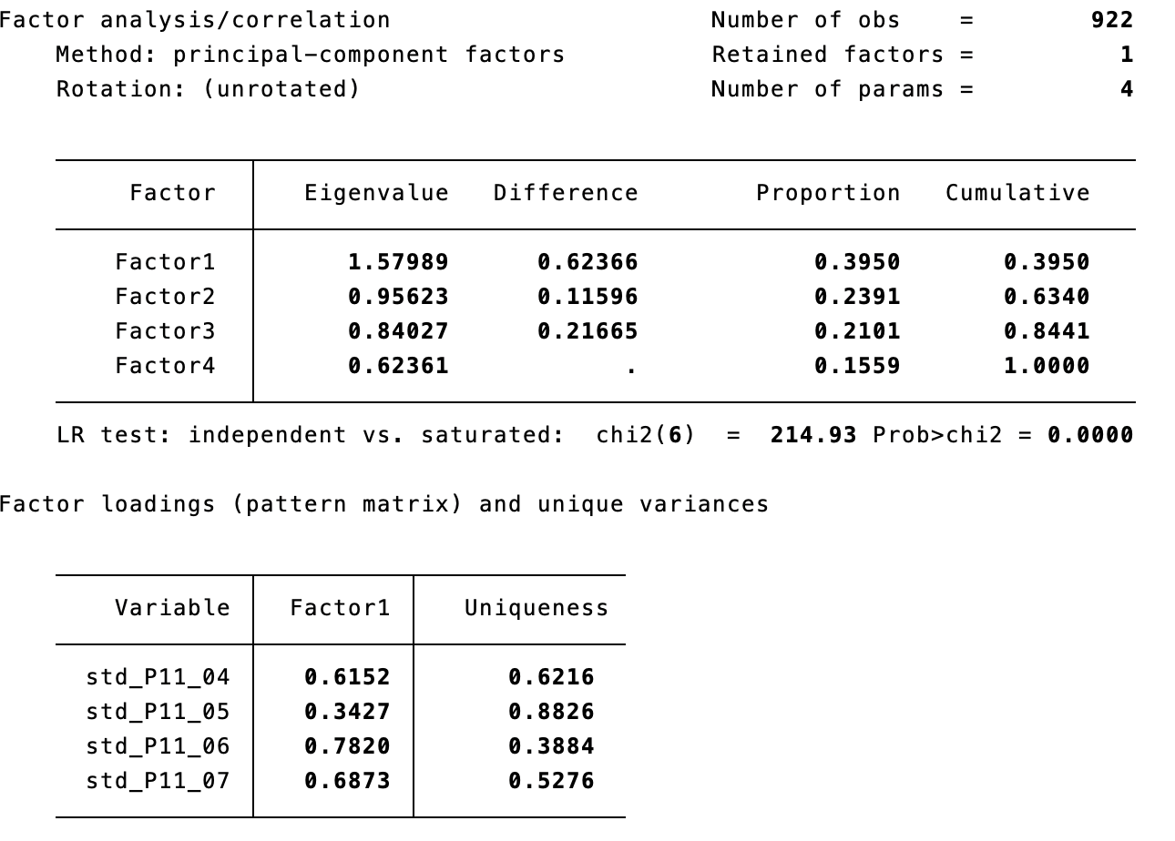

**Hungary**

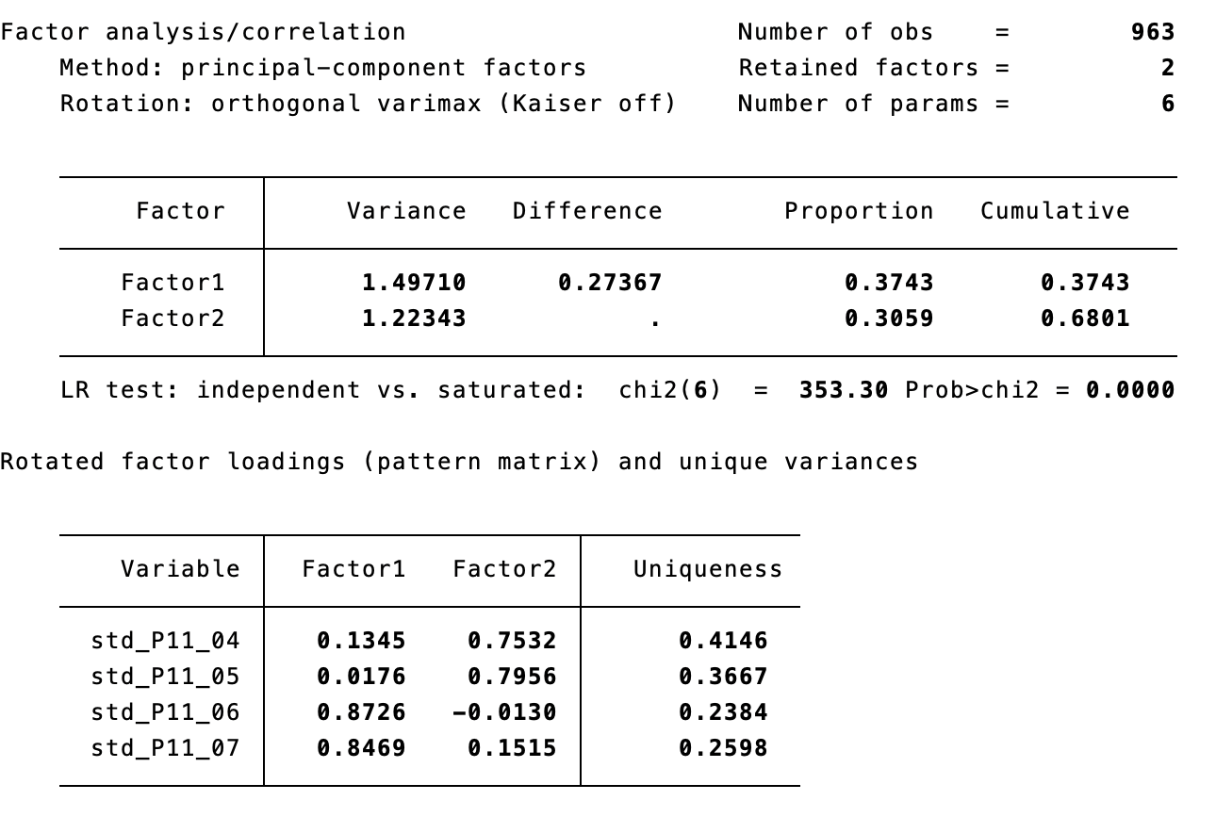

**Table A1** continued.

**Poland**

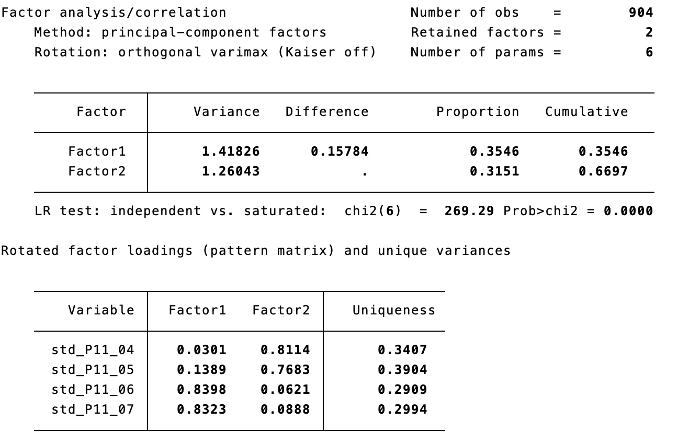

**Table A2**. PCA of illiberalism (country-by-country)

Variables:

P4_03. Women should be prepared to cut down on paid work for the sake of the family

P4_04. Same‐sex marriages should be prohibited by law

P4_05. Women should be free to decide on matters of abortion [Reversed]

P4_06. Teaching teenagers about tolerance towards transgender and homosexual minorities in schools can cause harm

P4_07. These days you cannot even say what you think about immigrants, women or gays without being called prejudiced

P4_08. Those who don't believe in God are not suitable for governing this country

P12_01. What our society needs is protection against international influences, not further opening up

P12_02. Leaders should always follow the interests of their country, even if this means going against international rules

P12_03. It is impossible for an organisation to serve the interests of our nation if most of its funding comes from foreign sources

P12_04. Those who claim that there are powerful organisations in the world which conspire against [Country] have a good point.

P12_05. These days the leading contribution white people have made to human culture is being downplayed

P6. Immigrants bad for the economy

P7. Immigrants bad for culture

**Table A2** continued.

**Italy**

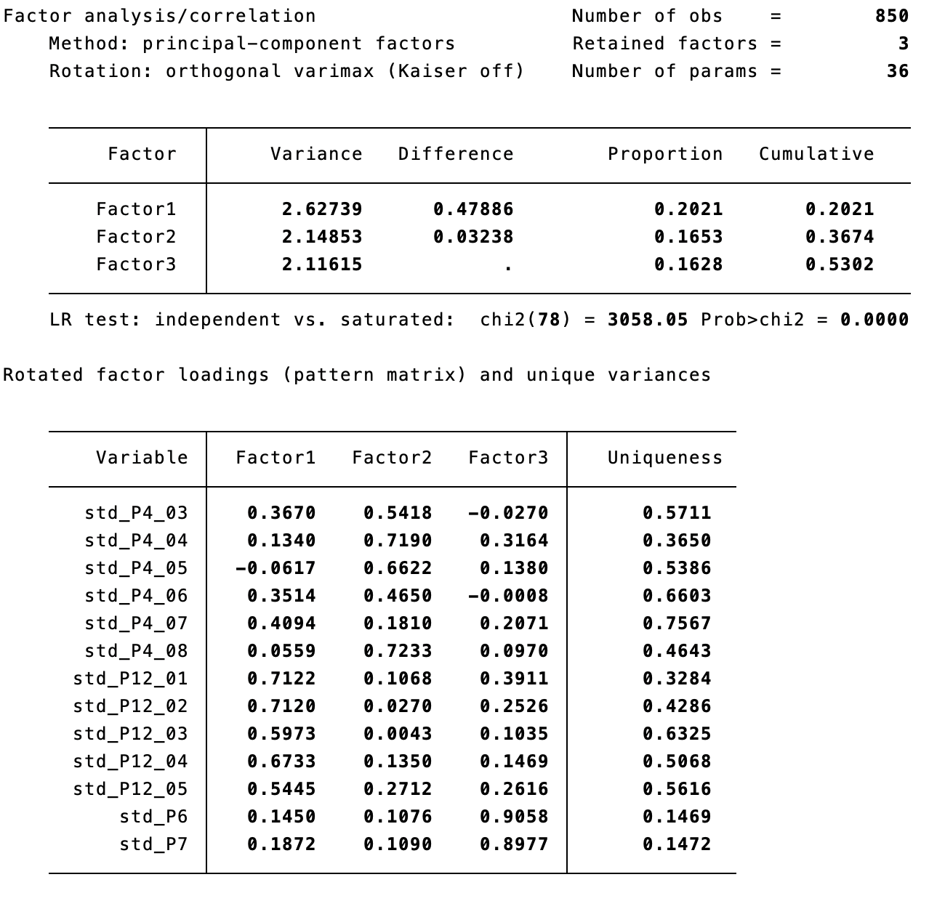

**Czechia**

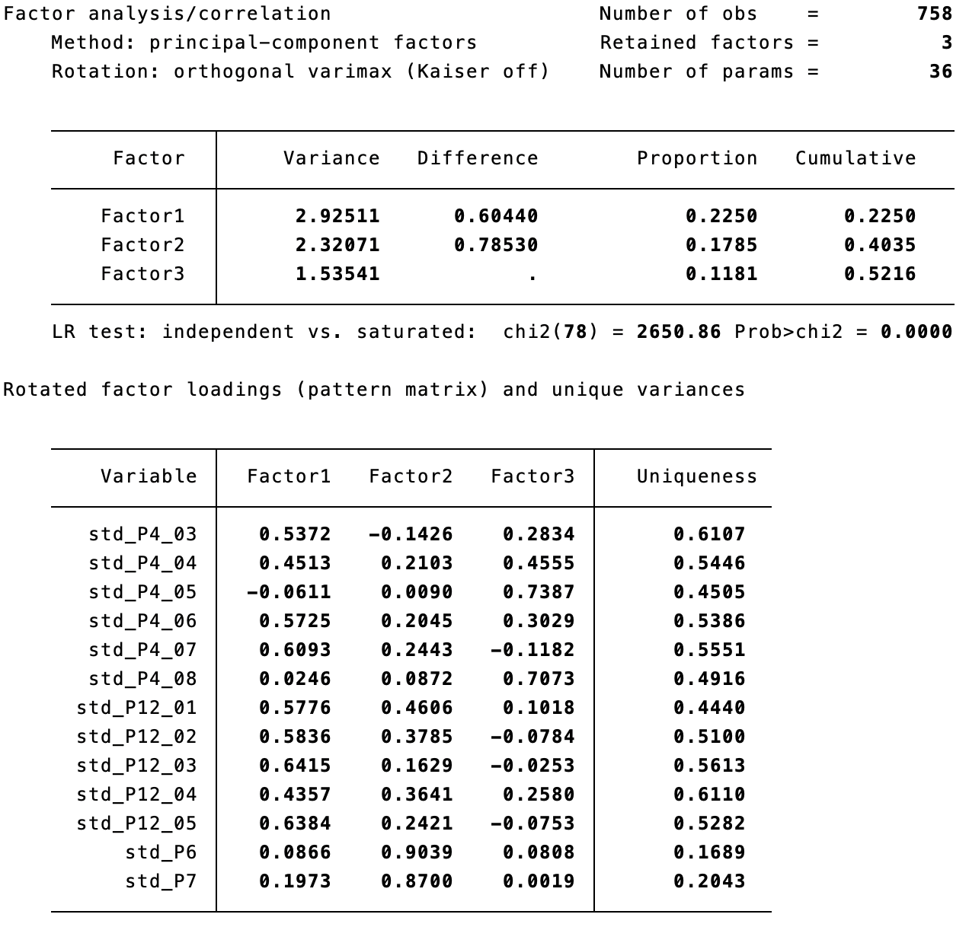

**Table A2** continued.

**Austria**

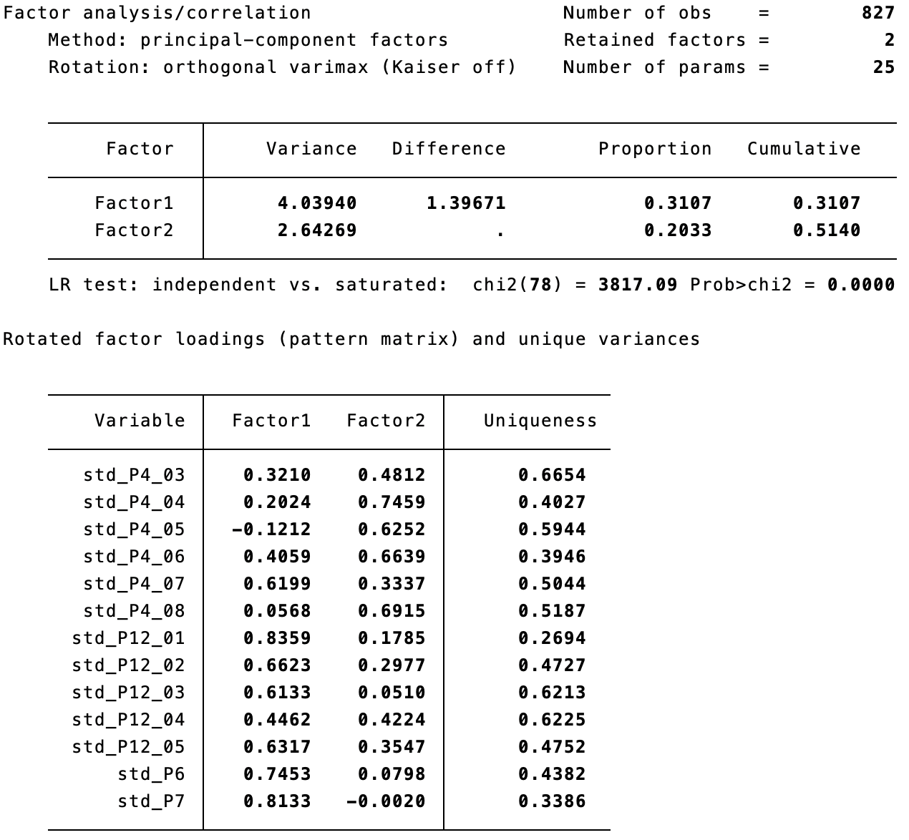

**France**

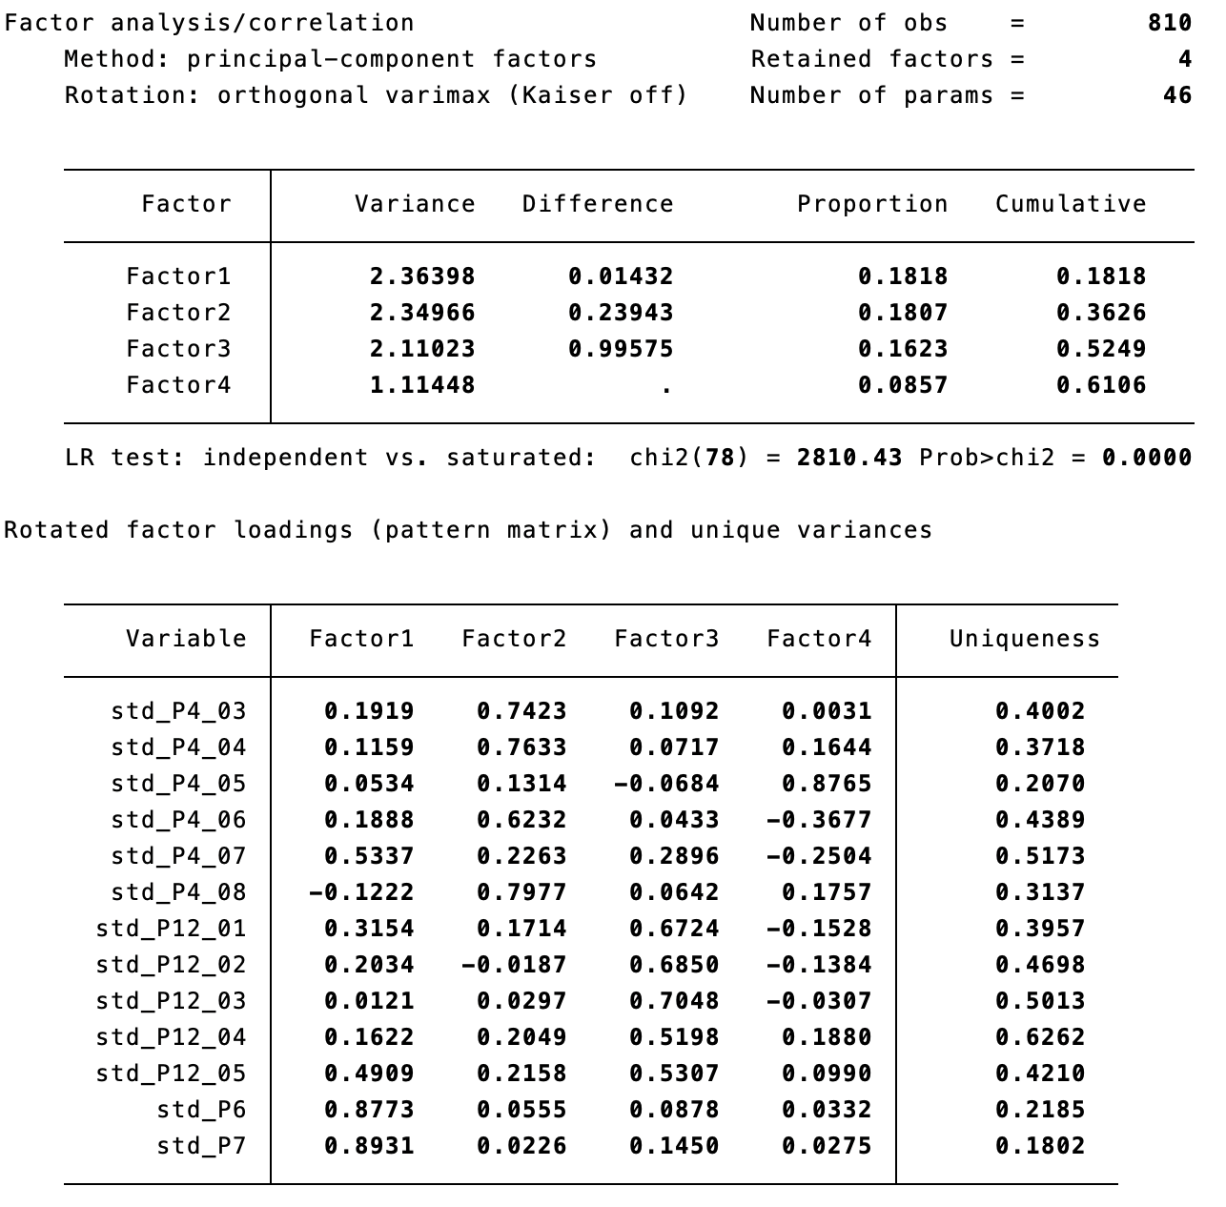

**Table A2** continued.

**Great Britain**

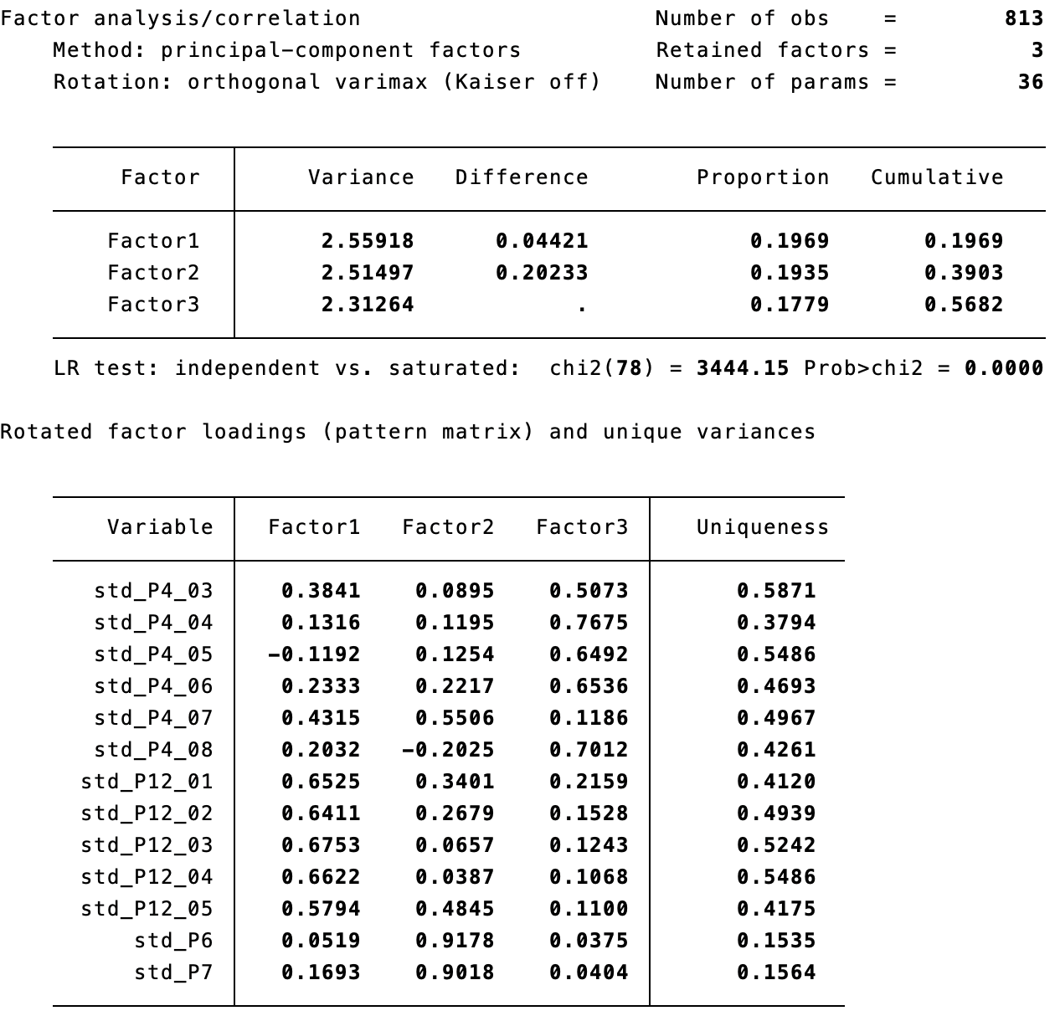

**Hungary**

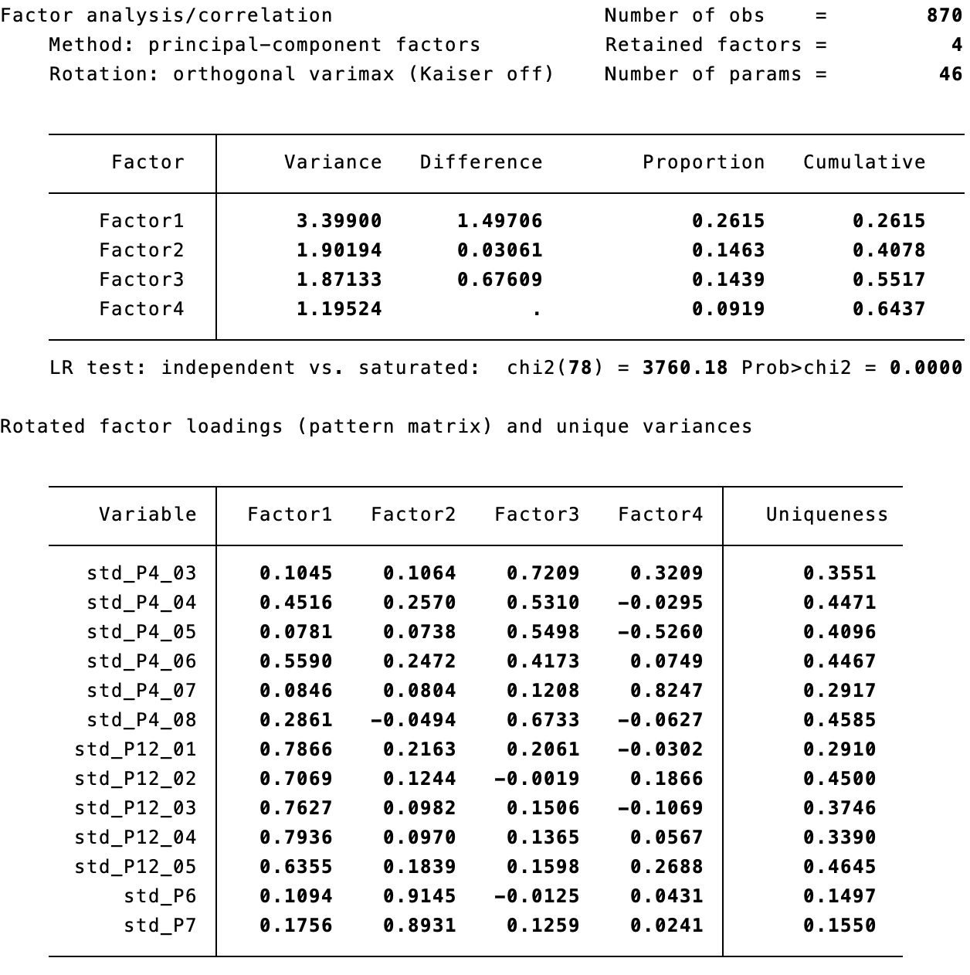

**Table A2** continued.

**Poland**

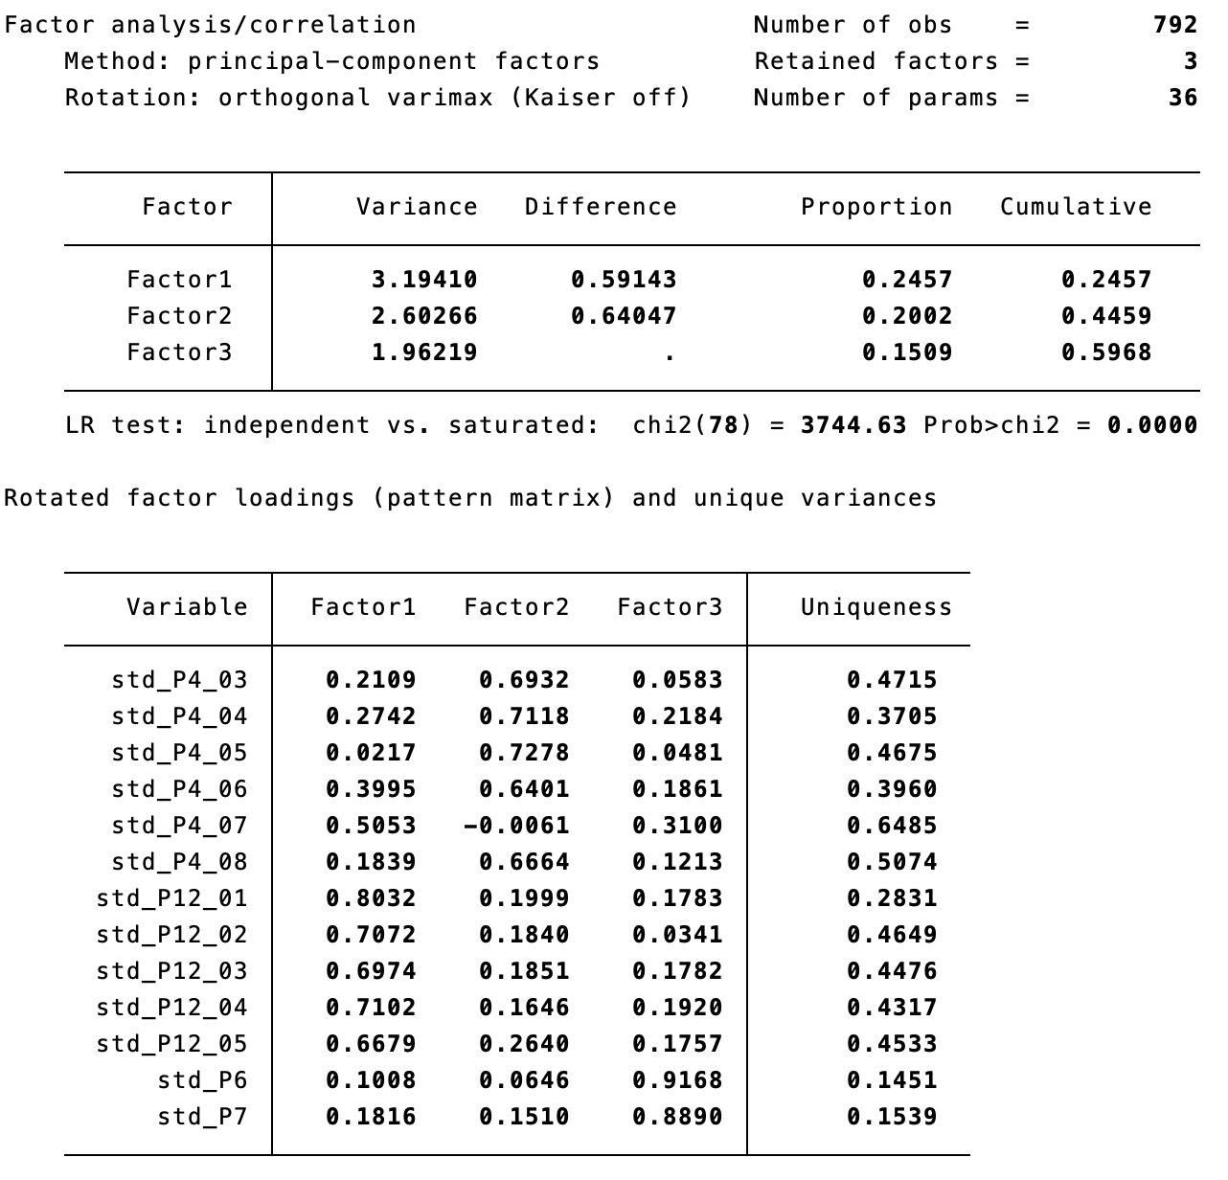

**Table A3**. PCA of authoritarianism (country-by-country)

Variables:

P3. How acceptable for you would it be for the [Country] to have a strong leader who is above the law?

P11_08. The government should be able to bend the law in order to solve pressing social and political problems

P4_01. Obedience and respect for authority are the most important virtues children should learn

P4_02. People who break the law should be given much harsher sentences than they are these days

**Table A3** continued.

**Italy**

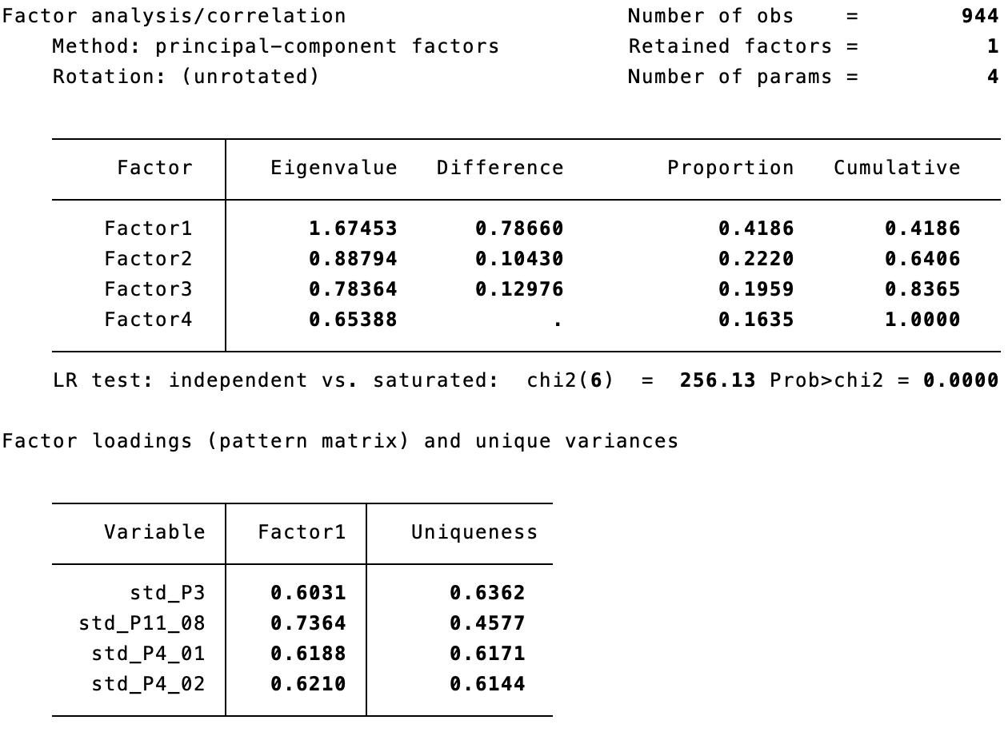

**Czechia**

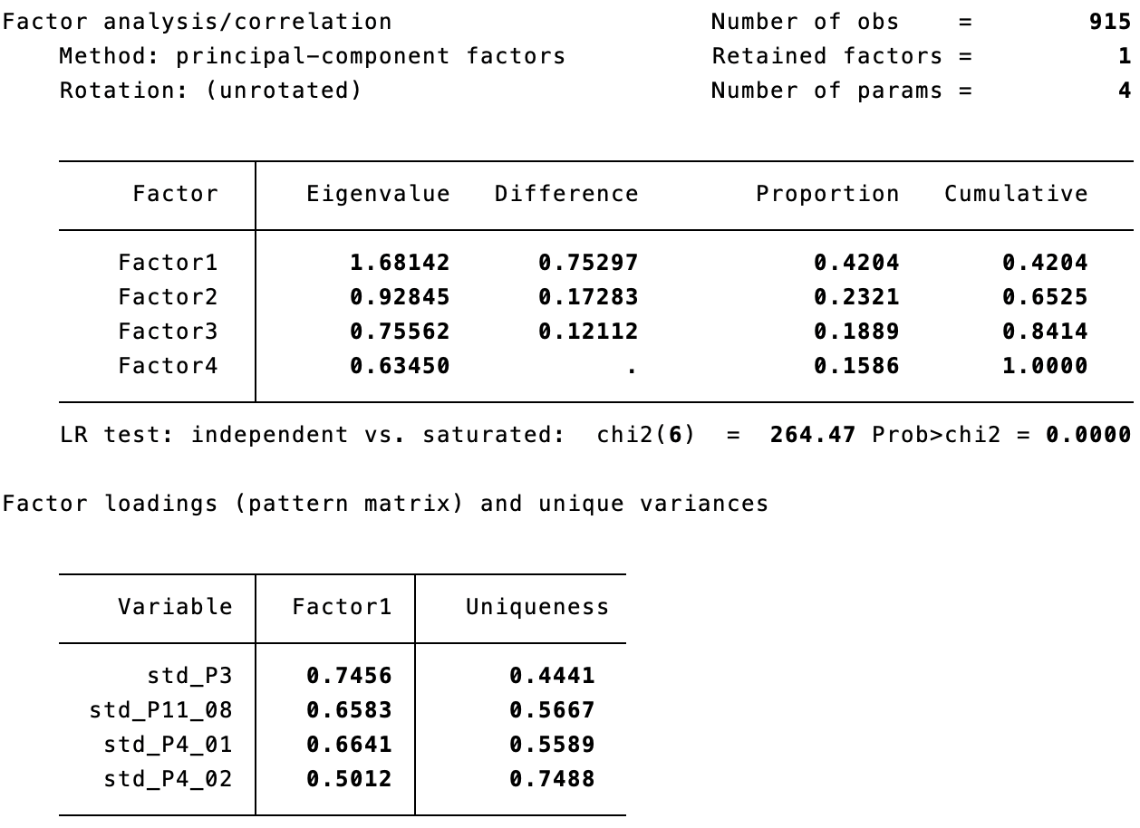

**Table A3** continued.

**Austria**

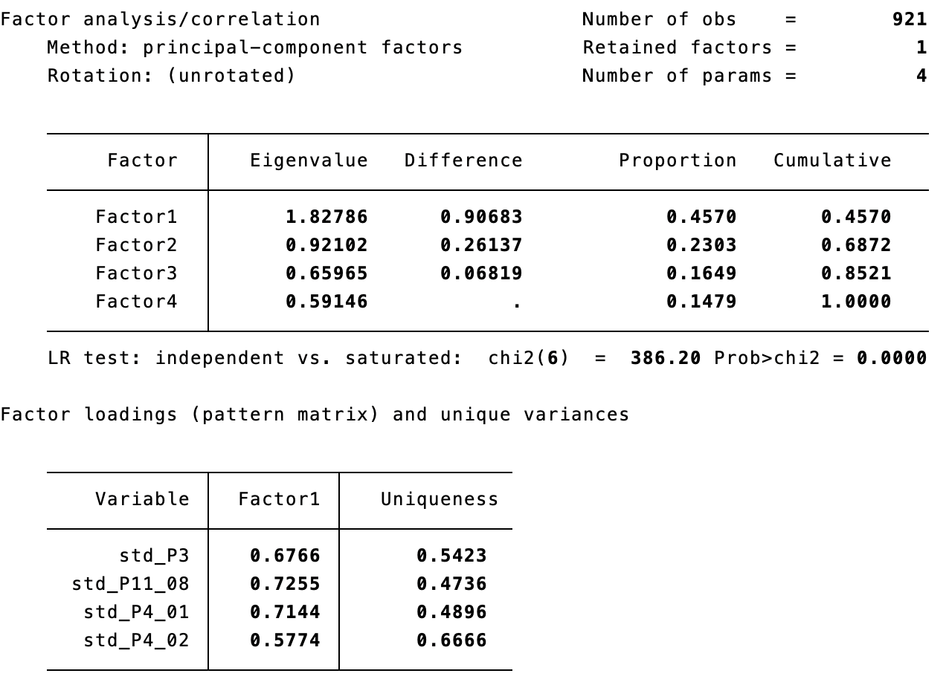

**France**

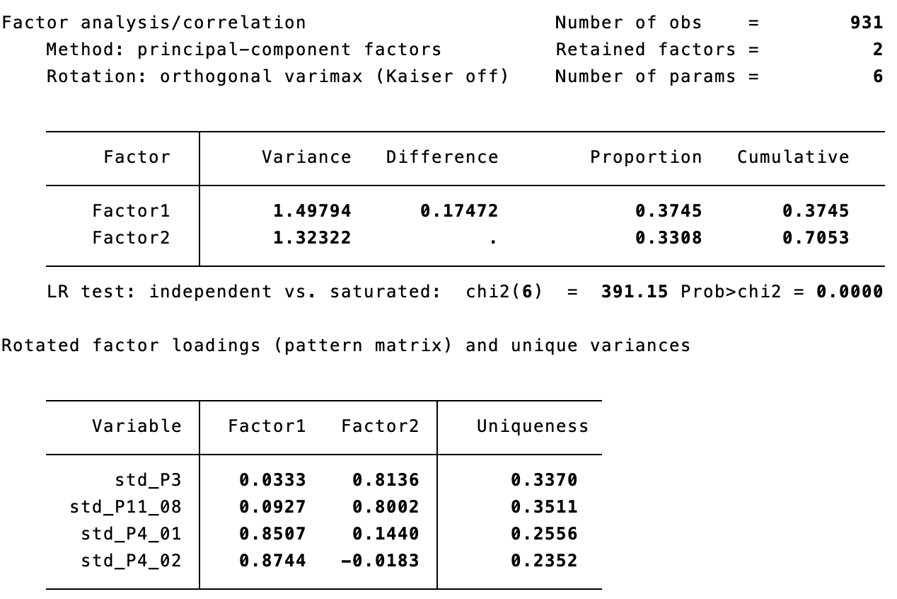

**Table A3** continued.

**Great Britain**

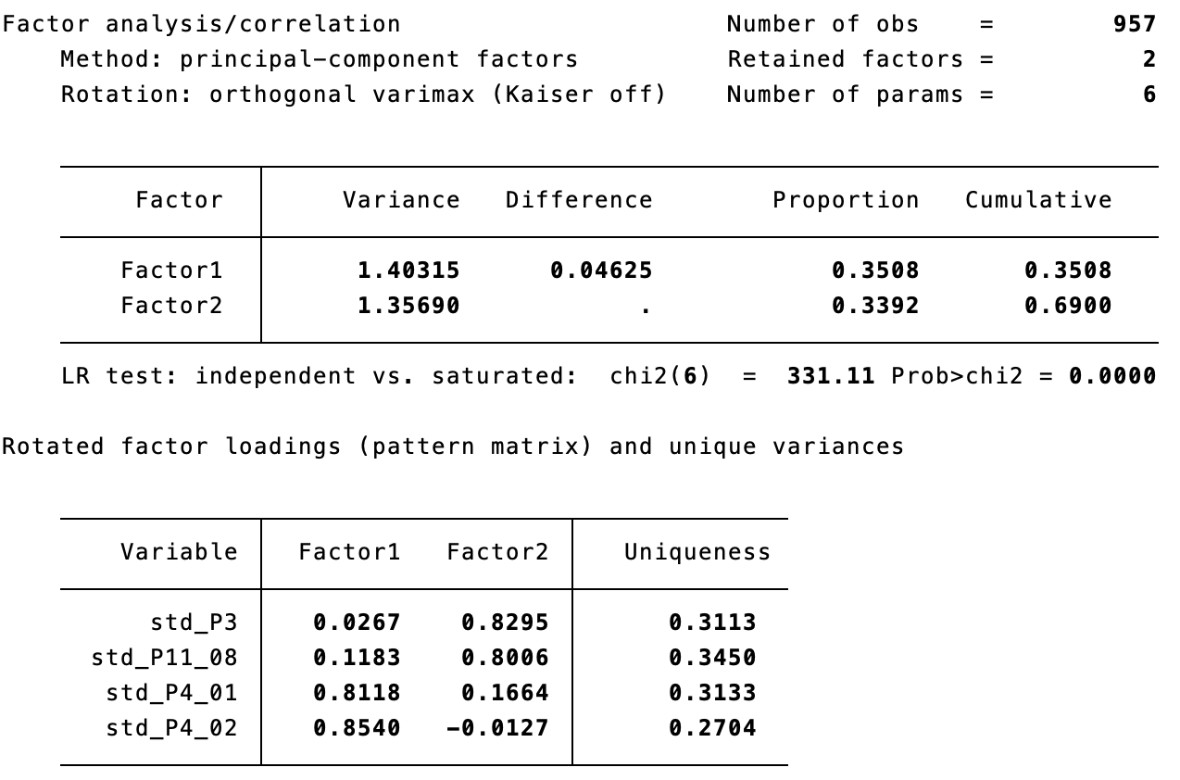

**Hungary**

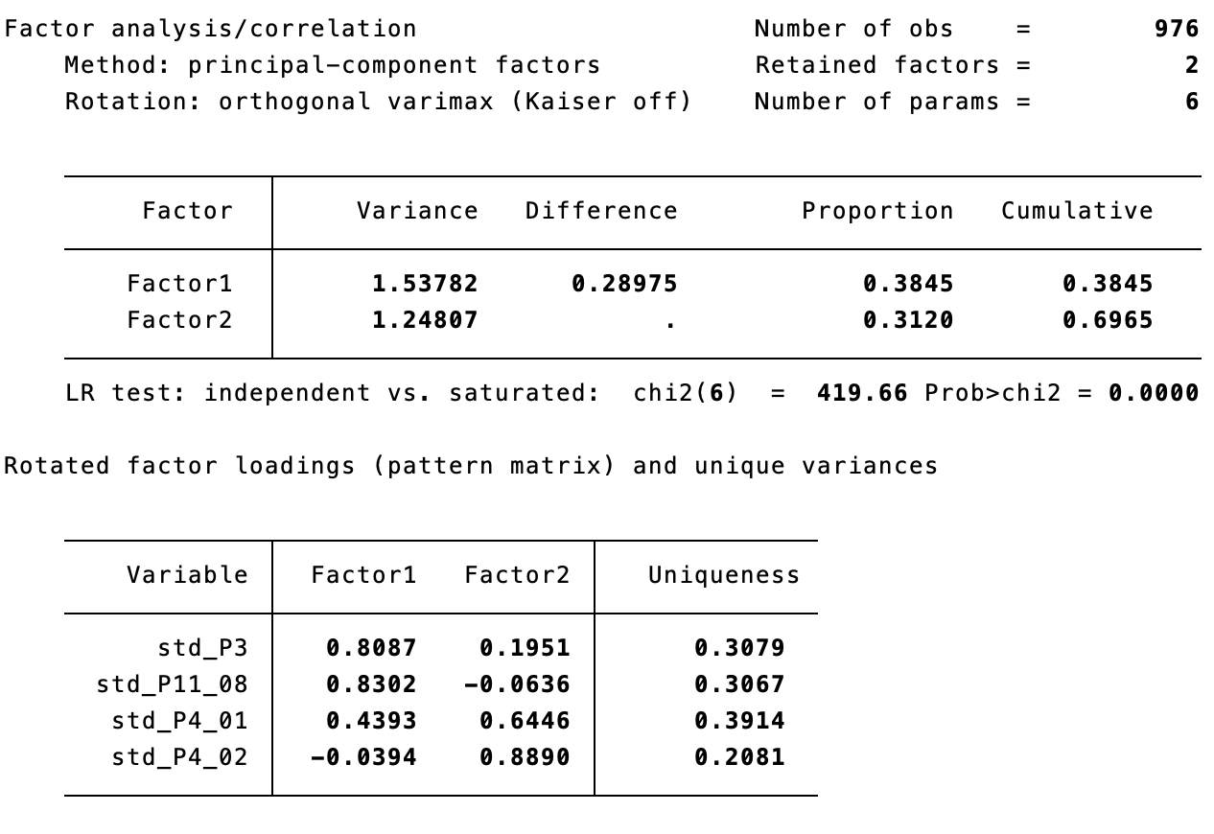

**Table A3** continued.

**Poland**

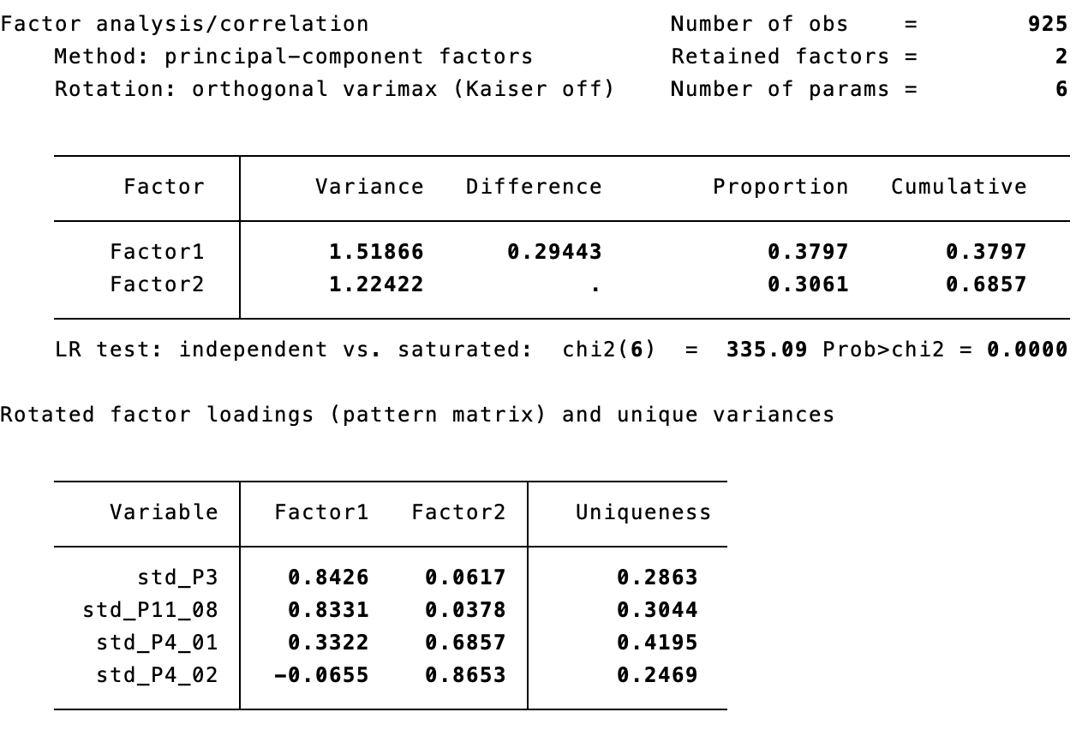

**Table A4**. Pairwise correlations between normative visions of democracy (not standardized, 0-10 scales) and PIA factors from Principal Component Analysis

|  |  |  |  |  |  |  |  |
| --- | --- | --- | --- | --- | --- | --- | --- |
|  |  | F1 POP  Simplistic Anti-Elitism | F2 POP  Manichean Majoritarian. | F1 ILL  State Parochialism | F2 ILL  Social Conservat. | F3 ILL  Nativism | F1 AUTH  Authoritar. |
| Referendum | P2_01 | **0.2902\*** | 0.0983* | **0.2002\*** | -0.0808* | -0.004 | 0.0591* |
| people>elite | P2_02 | **0.2631\*** | 0.0493* | 0.1780* | -0.0783* | -0.0453* | 0.0109 |
| people's will | P2_03 | 0.1868* | 0.0855* | 0.1563* | -0.0799* | -0.0381* | 0.0294* |
| free media | P2_04 | 0.1623* | -0.0891* | -0.0229 | -0.1950* | -0.0861* | -0.1656* |
| minorities' rights | P2_05 | 0.0321* | -0.1393* | -0.1052* | -0.1980* | **-0.3213\*** | -0.0894* |
| courts equally | P2_06 | 0.1197* | -0.0819* | -0.0161 | -0.1874* | -0.0871* | -0.1028* |
| freedom to protest | P2_07 | -0.005 | -0.0516* | -0.0491* | -0.1109* | -0.1673* | -0.0712* |
| everyone votes | P2_08 | -0.002 | 0.0025 | 0.0537* | -0.0921* | -0.1211* | -0.0562* |
| religious symbols | P2_09 | -0.0570* | -0.0576* | -0.0796* | 0.0568* | **-0.2836\*** | -0.0243 |
| obey rulers | P2_10 | -0.1258* | 0.1172* | 0.0913* | 0.1232* | -0.0981* | **0.2433\*** |
| religious laws | P2_11 | -0.0722* | 0.1646* | 0.1257* | **0.2362\*** | -0.1251* | **0.2283\*** |

Note: *0.05 sig., in bold correlations >0.2

1. In the text we will mostly cover the three concepts – populism, illiberalism and authoritarianism, for the sake of space referring to all of them we will however either use their acronym (PIA) or use the term "anti-liberalism/st" (types of…), covering its populist, illiberal and authoritarian variants.